

Assignment 2

____________________________________________________

COS 20019- Cloud Computing Architecture

Nguyen Manh Dung

Student ID: 104181789

Tutorial Class :Saturday 13:00PM – 17:00PM

12/7/2023

1. Introduction

This assignment will extend/modify the infrastructure and program you developed in Assignment 1b.

The essay seeks to accomplish a number of goals. In order to ease communication and ensure safe data transmission between EC2 (Elastic Compute Cloud), Lambda, and S3 (Simple Storage Service), we will first look at the creation of IAM (Identity and Access Management) roles. Second, we'll go through how to build S3 bucket policies to limit access to particular people or groups and manage S3 access. The development of a lambda function that may automatically run code in response to particular triggers is the focus of our third subject.

The essay seeks to accomplish a number of goals. In order to ease communication and ensure safe data transmission between EC2 (Elastic Compute Cloud), Lambda, and S3 (Simple Storage Service), we will first look at the creation of IAM (Identity and Access Management) roles. Second, we'll go through how to build S3 bucket policies to limit access to particular people or groups and manage S3 access. The development of a lambda function that may automatically run code in response to particular triggers is the focus of our third subject.

Seventh, we'll build an elastic load balancer with good workload distribution to govern system access. Finally, we'll look at network control and traffic limitations using Amazon NACLs (Network Access Control Lists), which permit or reject traffic depending on IP address, port, or protocol.

1. **Application Deployment**
2. **Infrastructure**
3. VPC configured with 2AZs both with public and private subnets. Public and private route tables route to IGW and NAT,respectively.

**Created VPC**

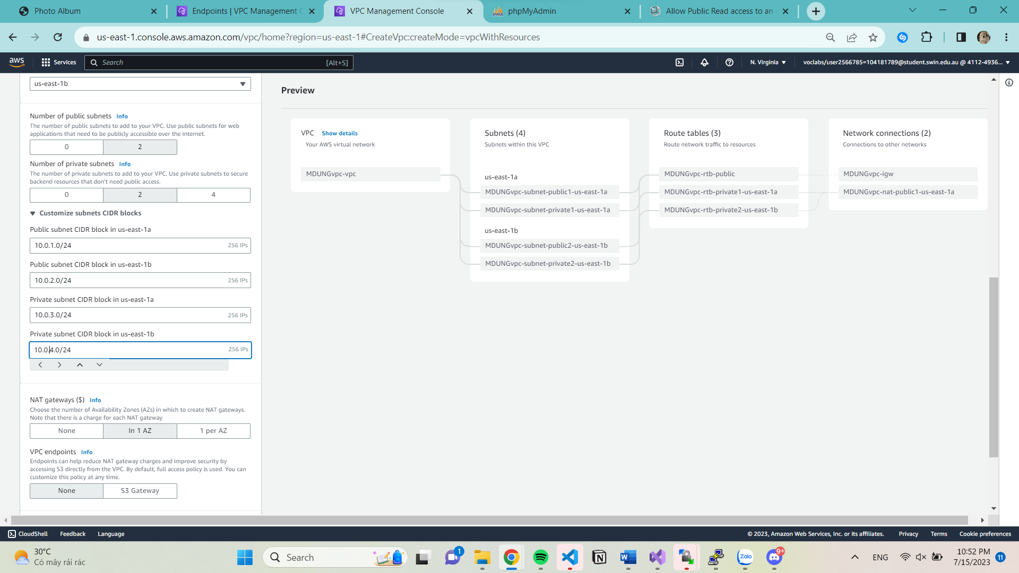

Below screenshotted illustrate VPC diagram

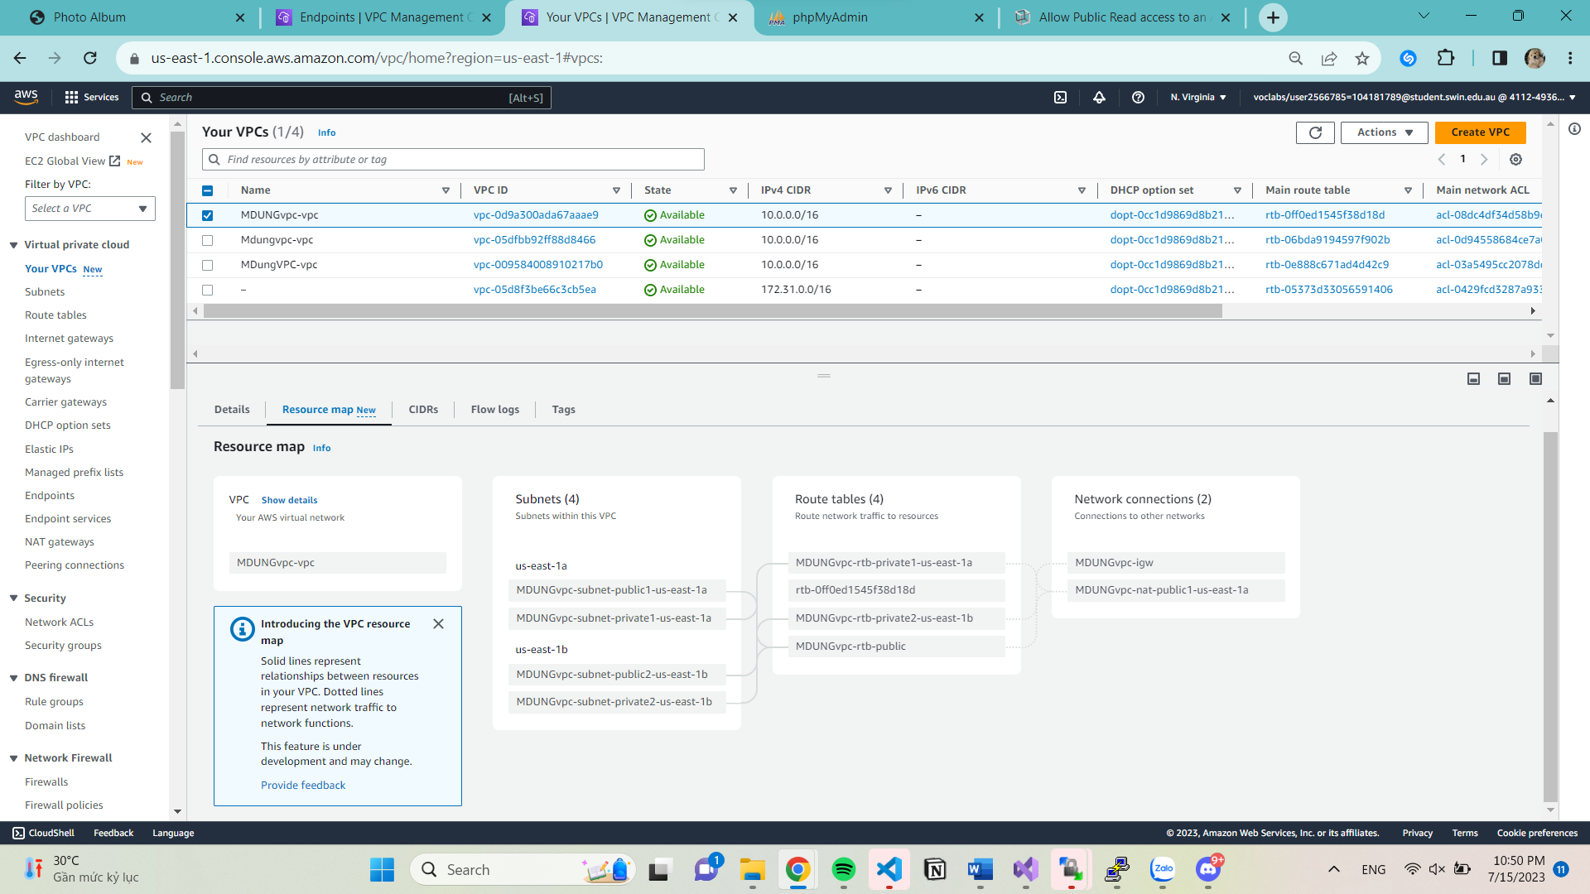

1. **Security Group**

**Create five security groups (I’ve configure inbound and outbound rules with same configuration**

* **ELBSG**: for the ELB created

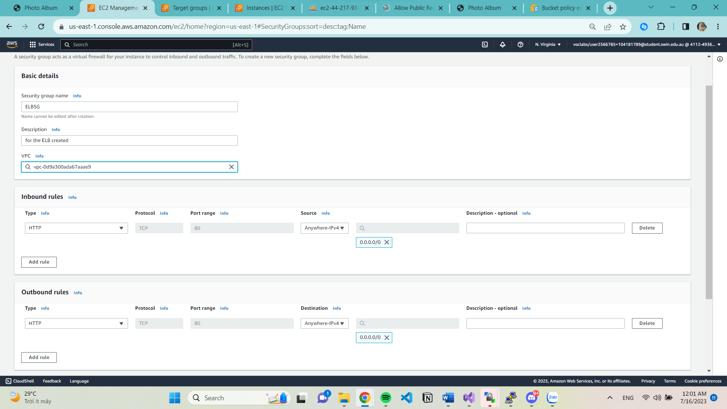

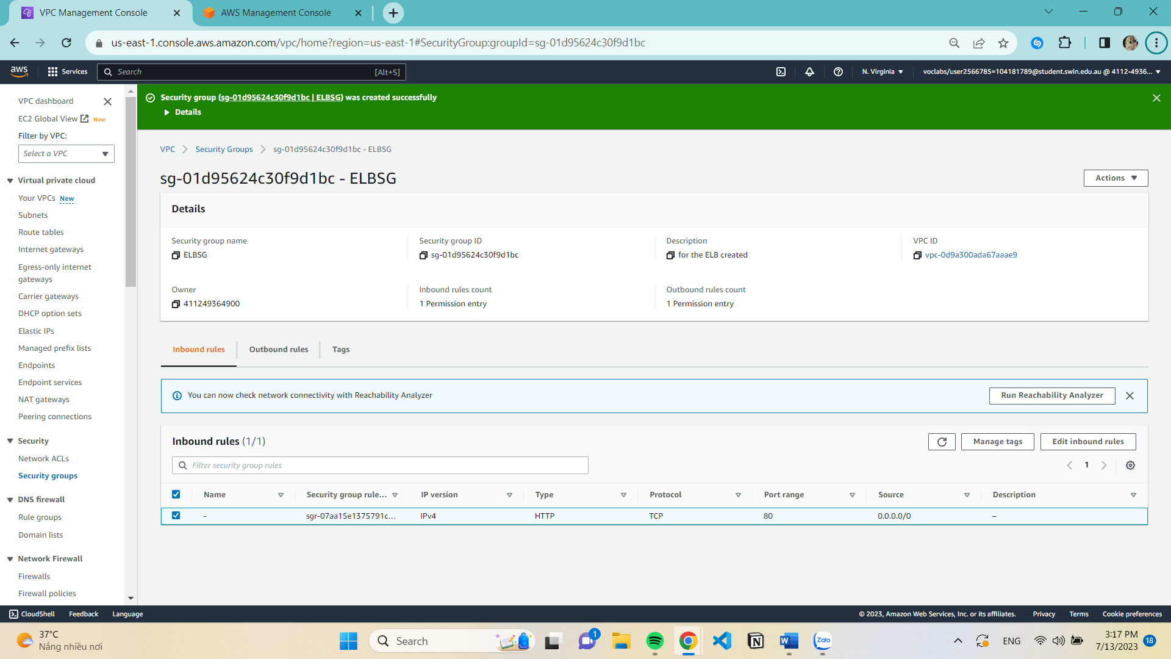 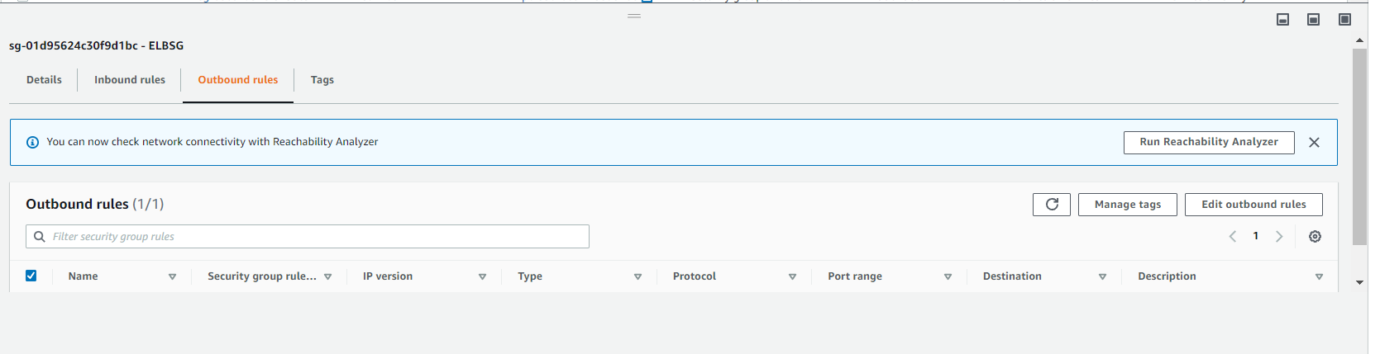

* **WebServerSG**: for all the web servers in private subnets

(Source is ELB security group)

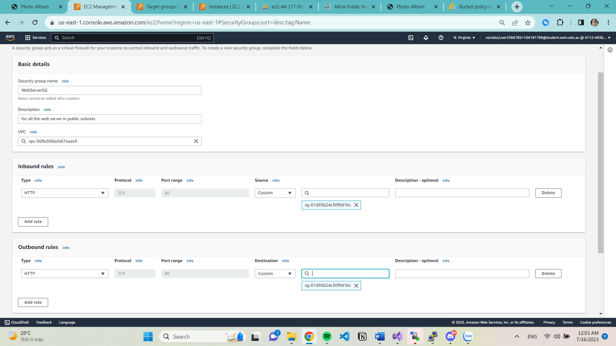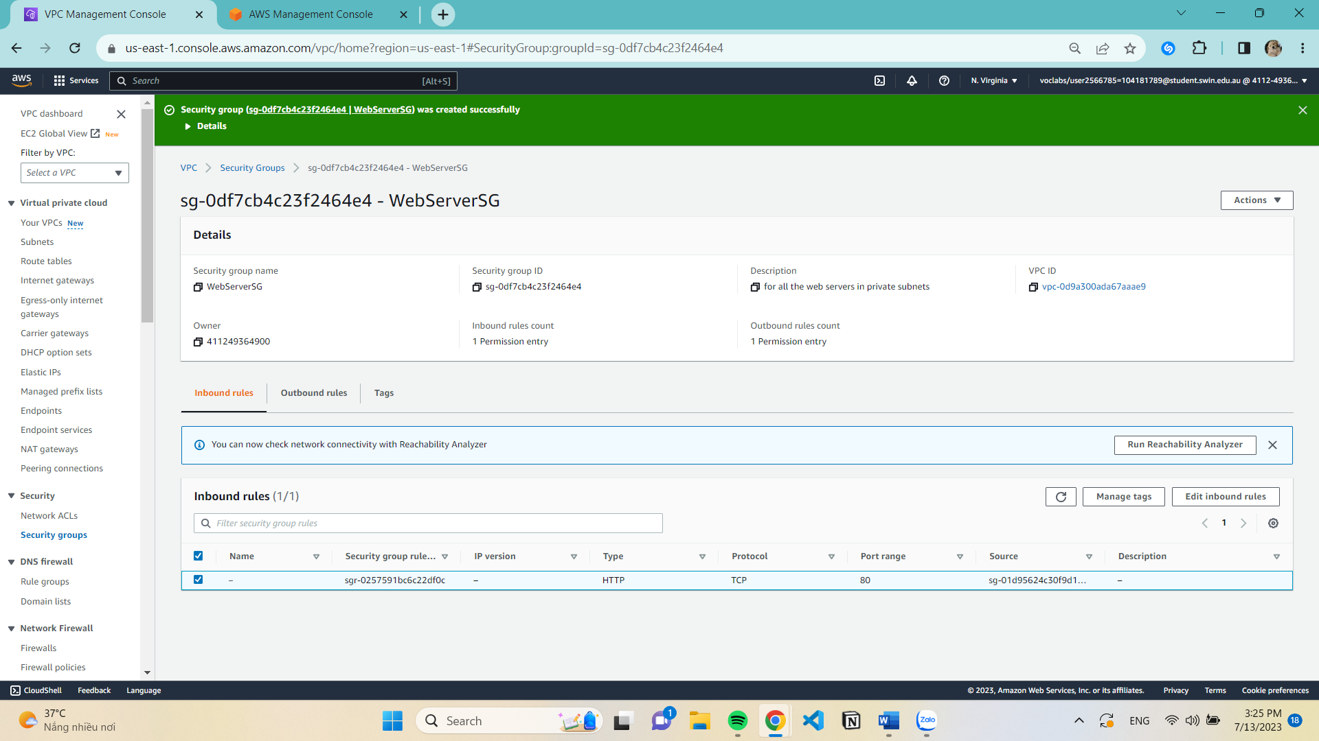 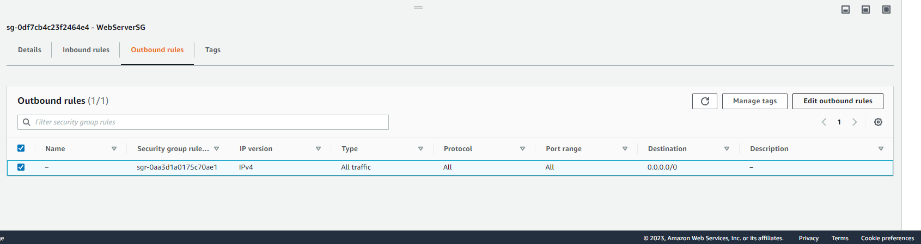

* **DBServerSG**: for the RDS instance (source is DevServerSG and WebServerSG)

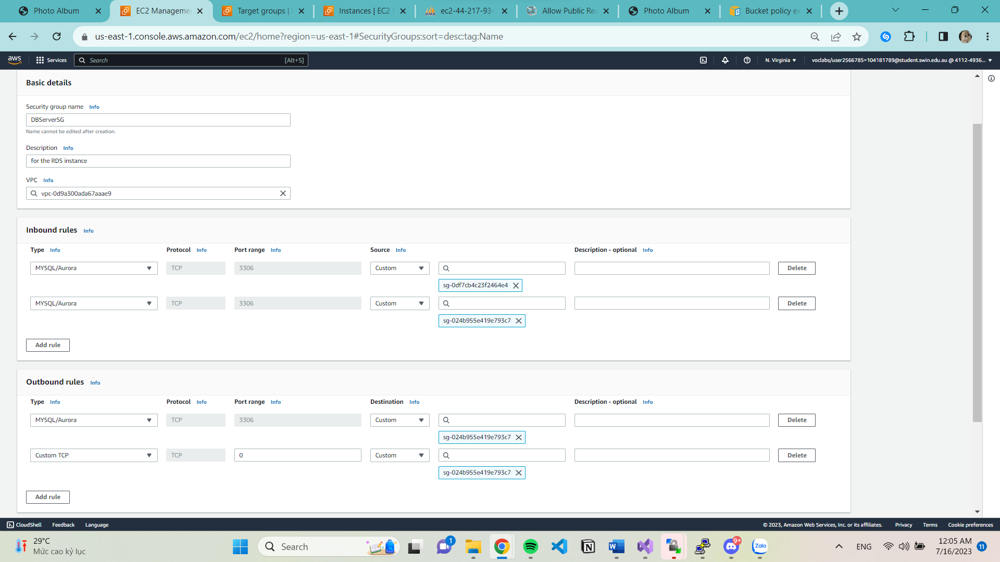 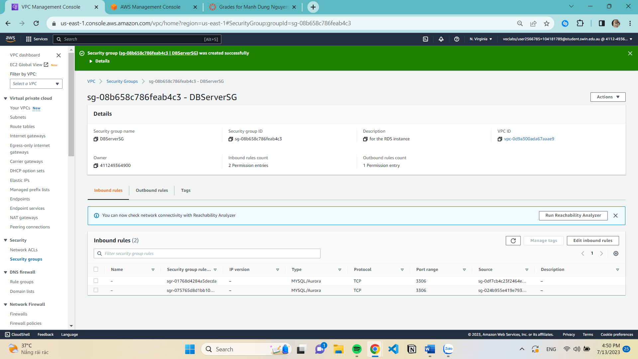

* **NATServerSG**: for the NAT server

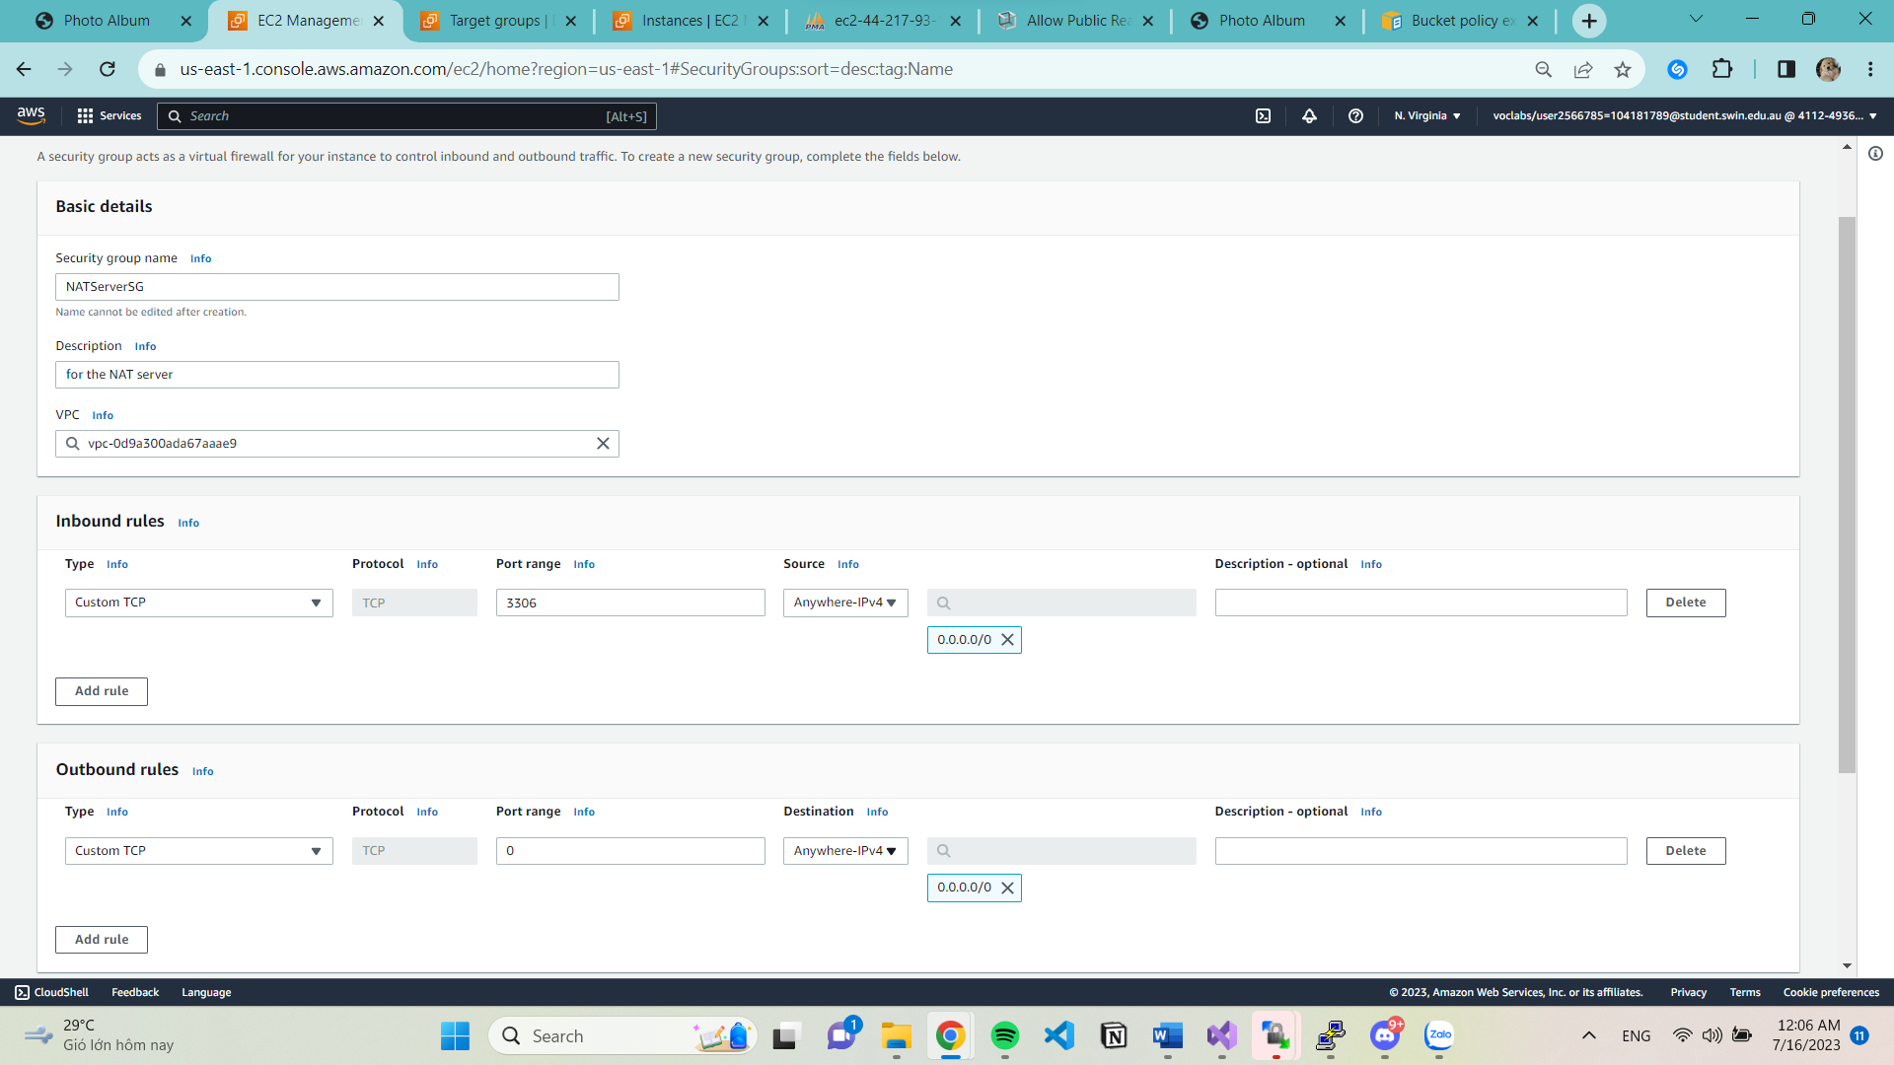 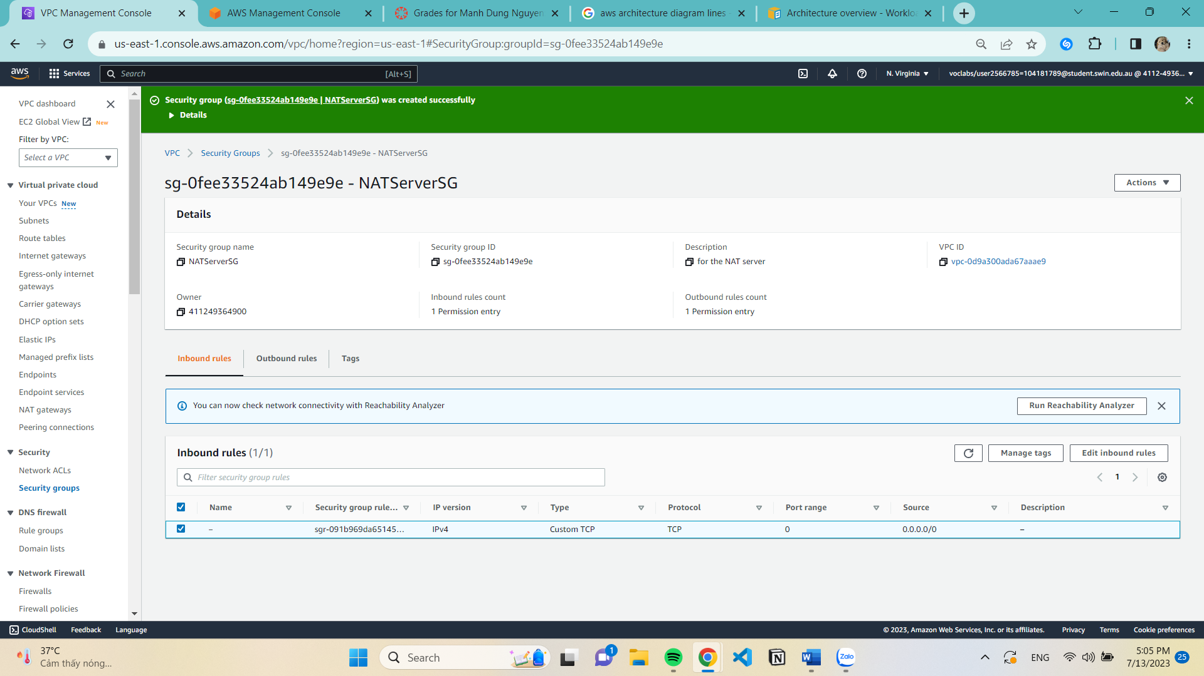 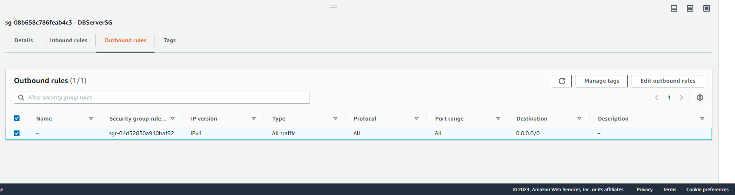

* **DevServerSG**: for the Dev server(all traffic)
* 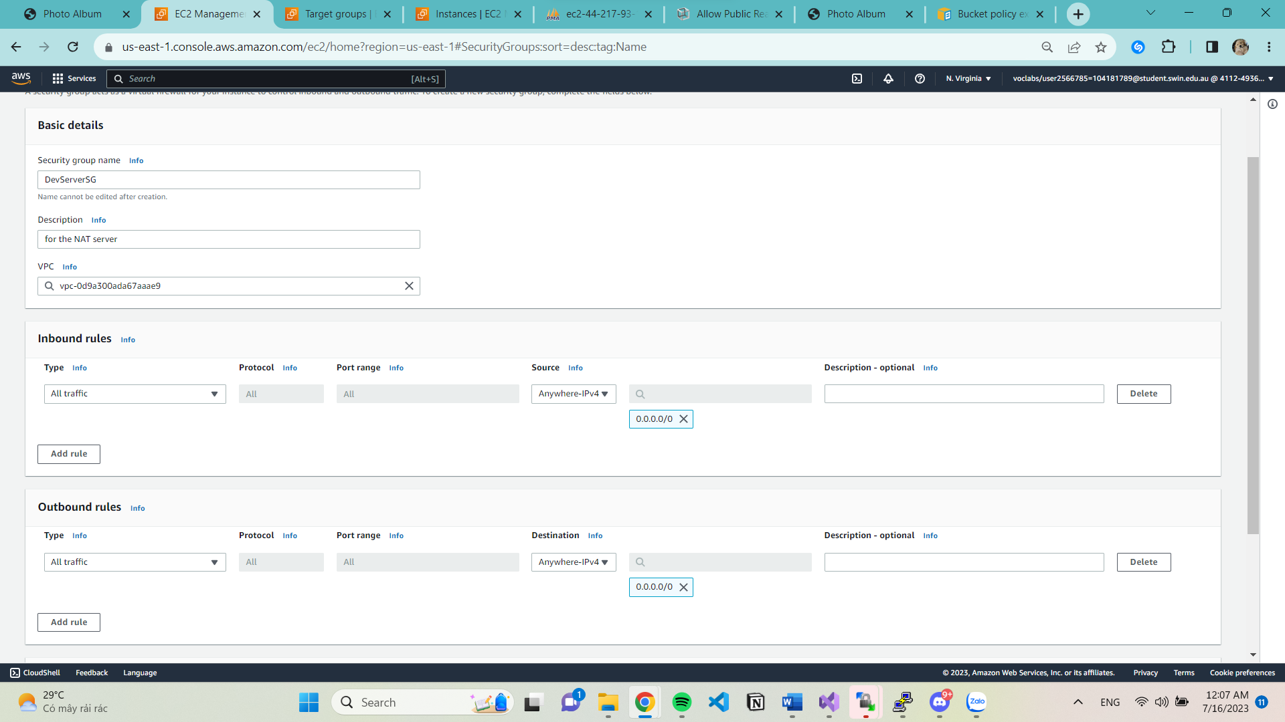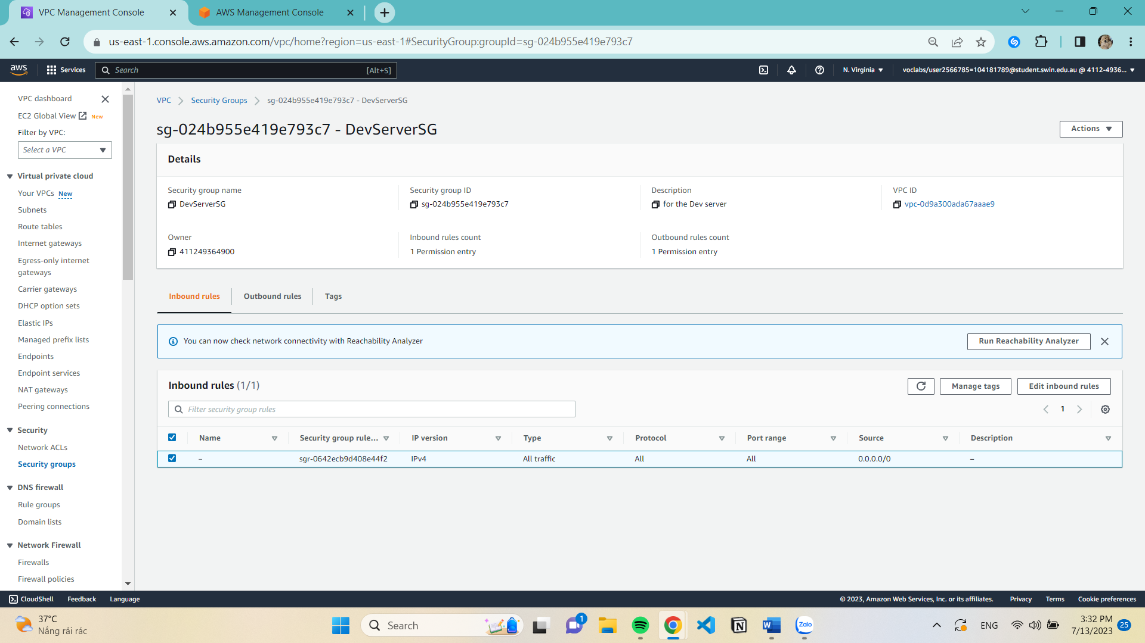 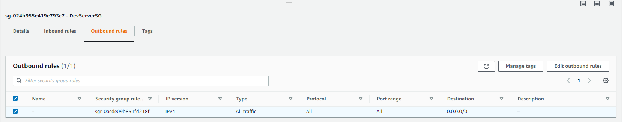

1. **Netword ACLs**

**Create NACL**

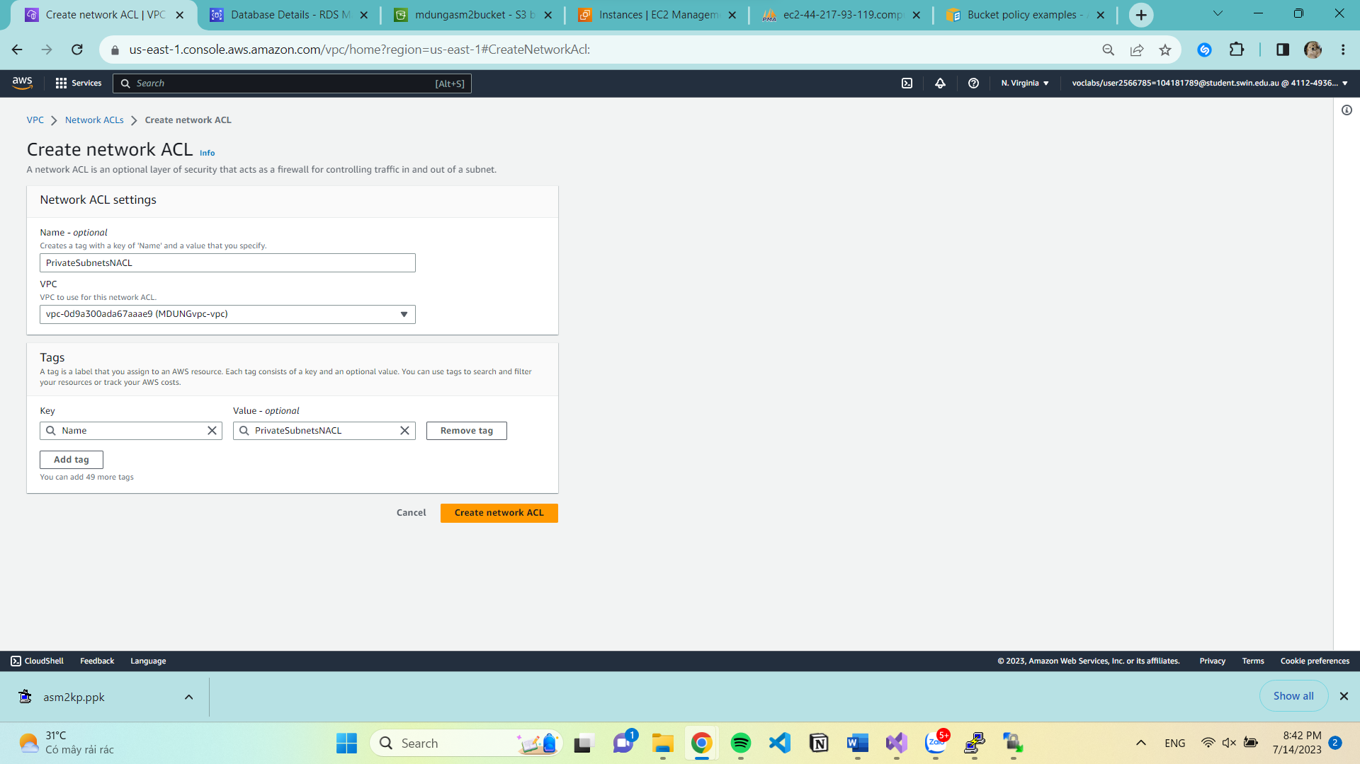

Edit subnet associations

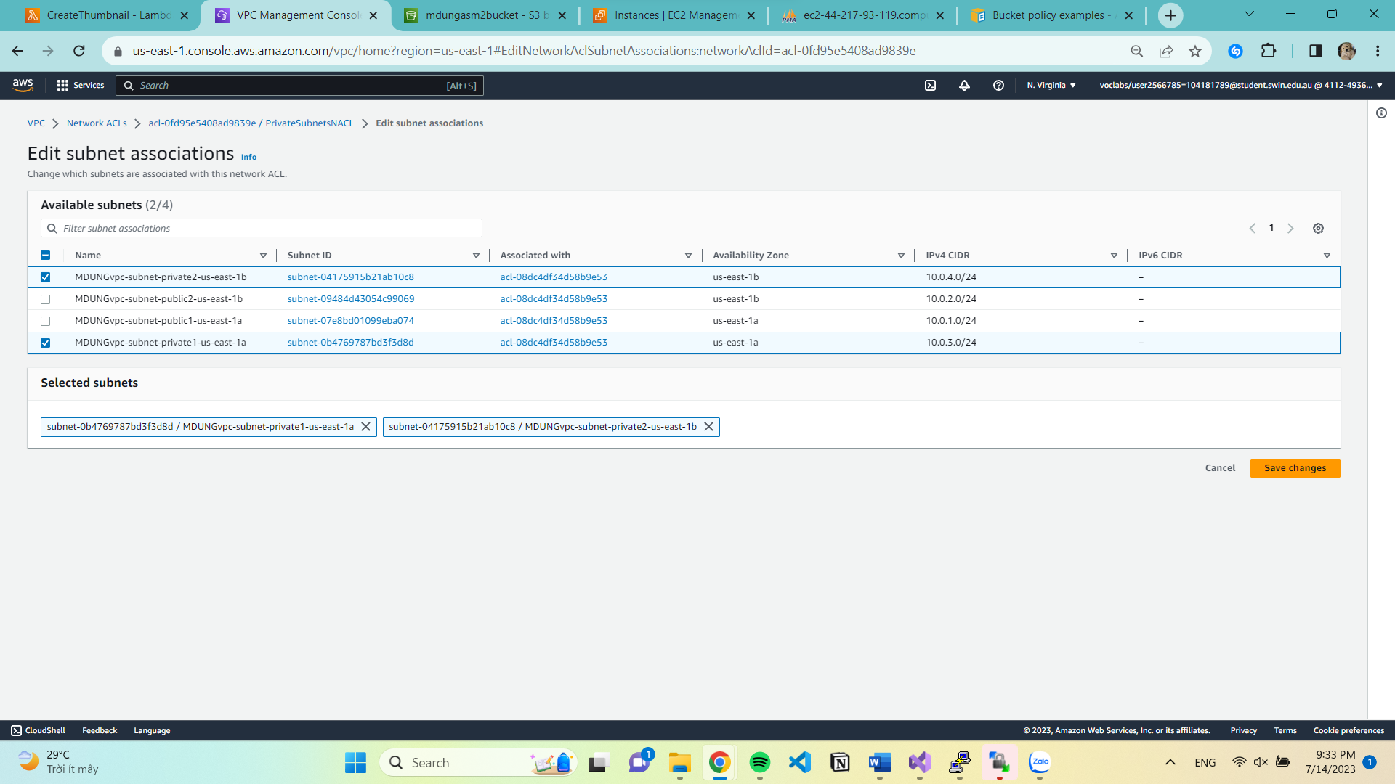

Edit rule

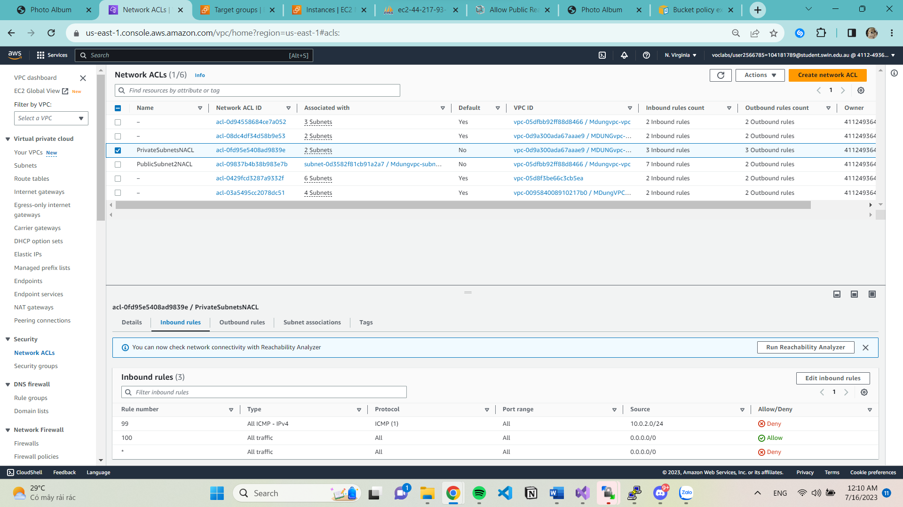 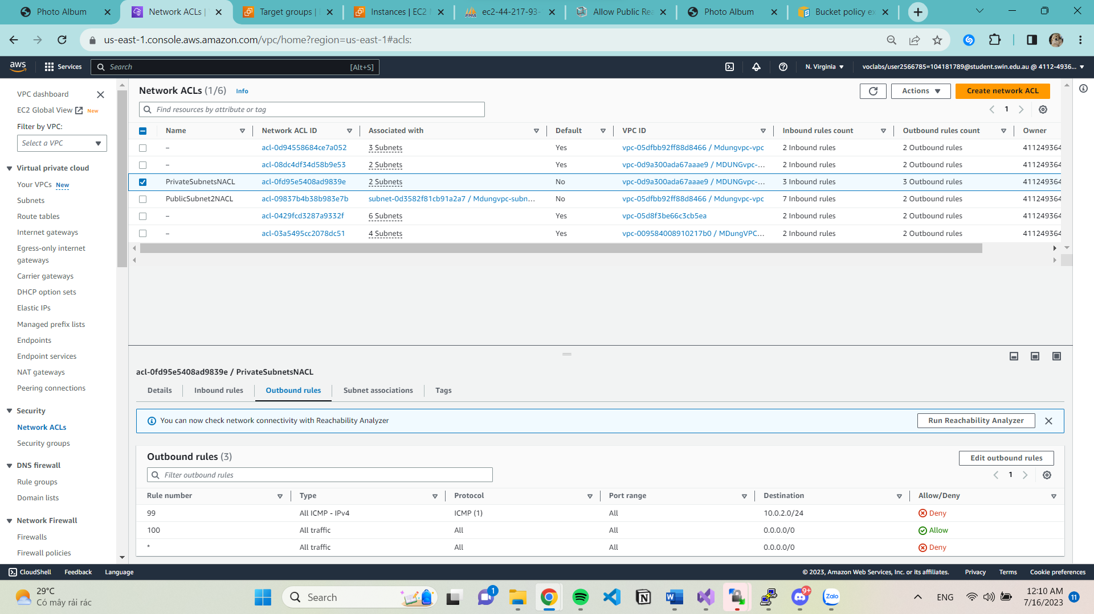

1. **S3 Photo Storage**

**Create Bucket**

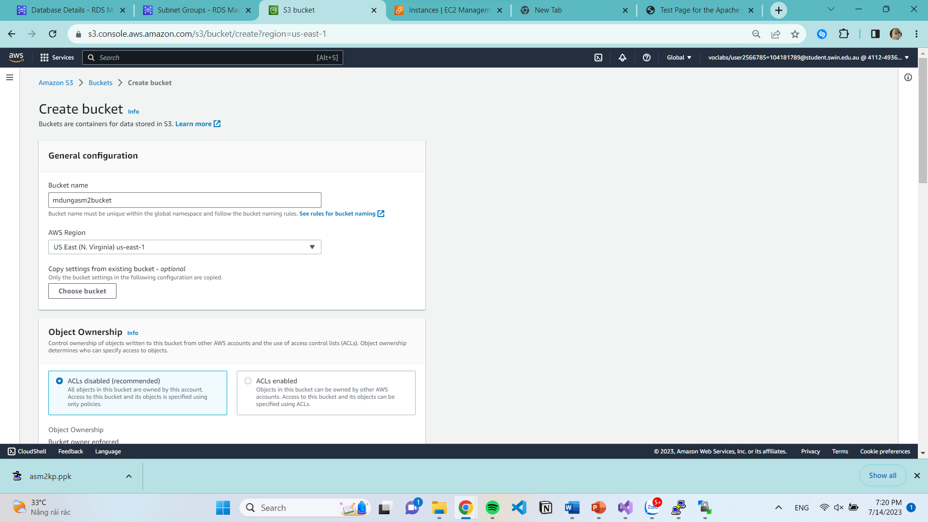

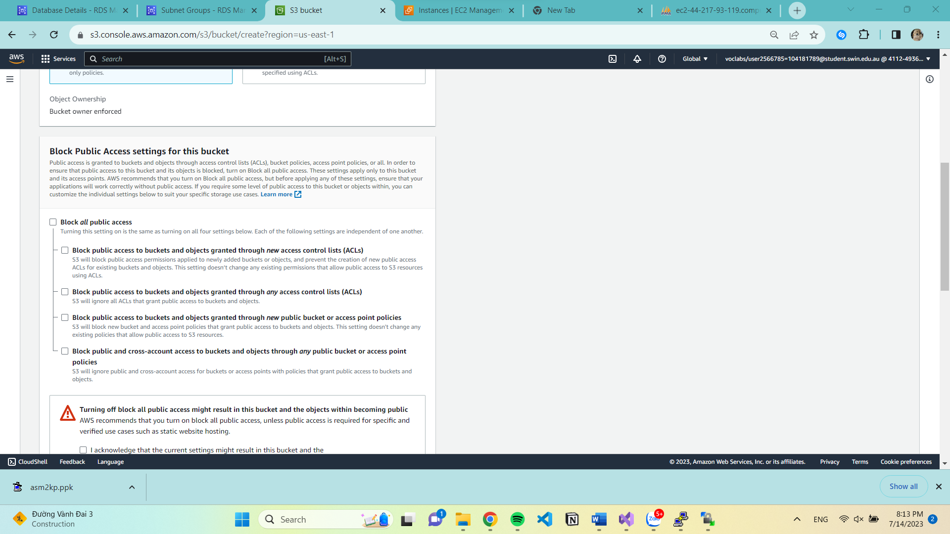

Modify IAM Role

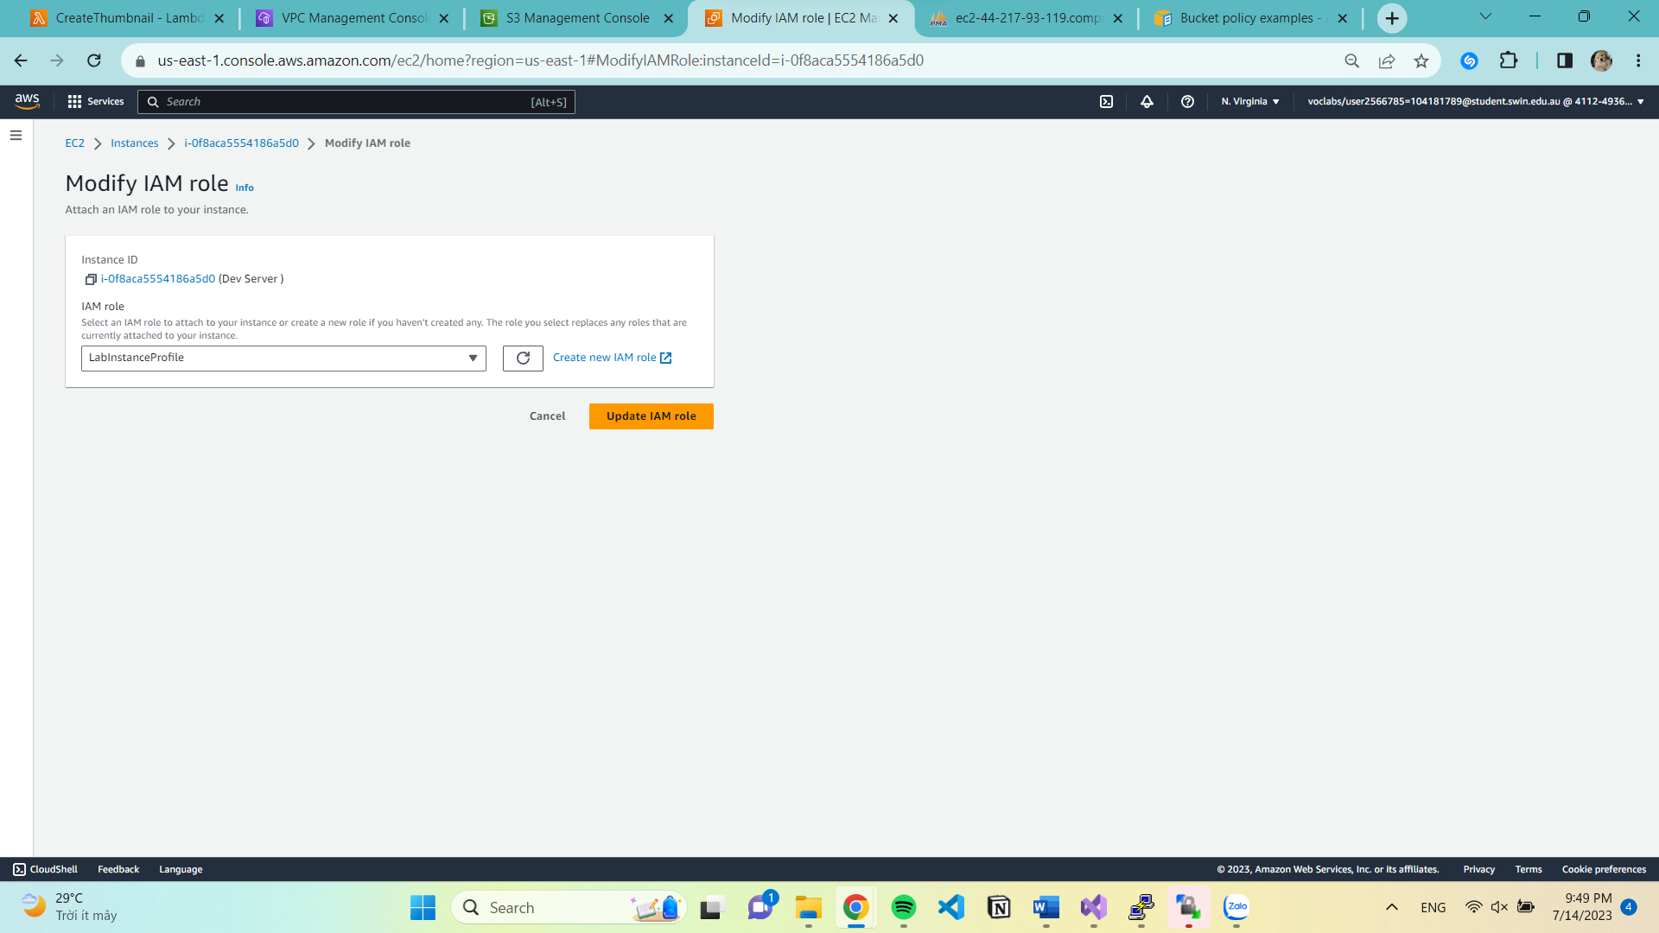

DevServer IAM Role

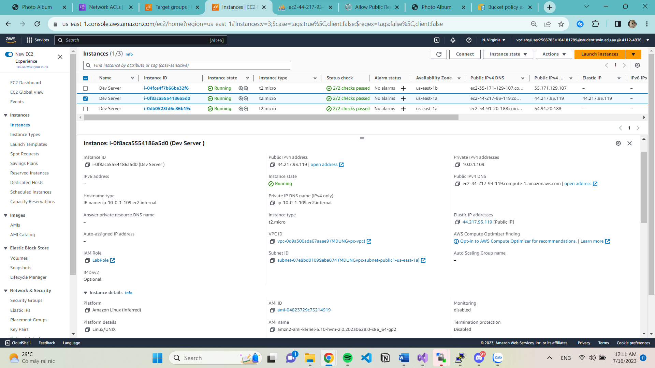

Lambda IAM Role

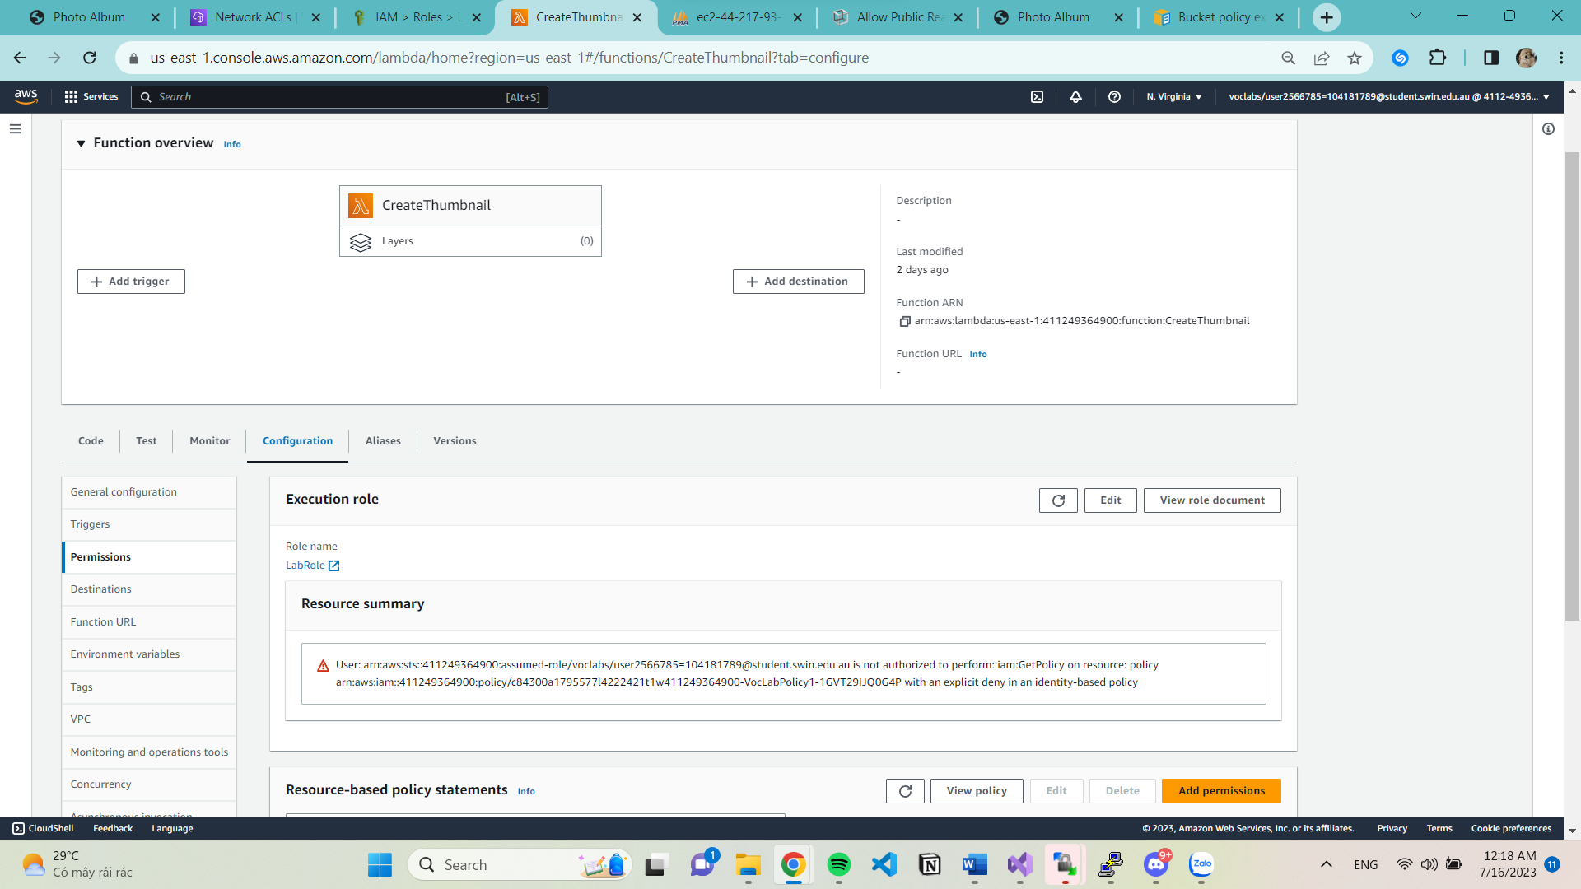

**ASM2 Launch Template**

Create launch template

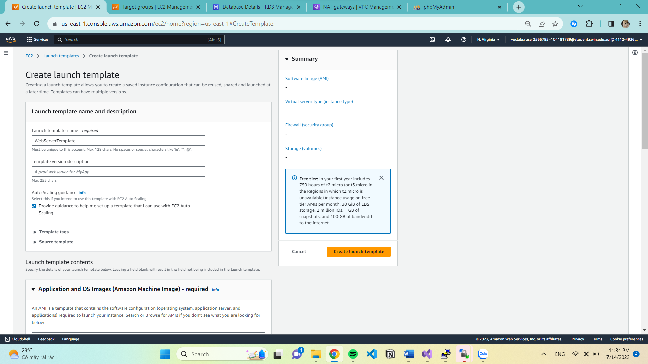

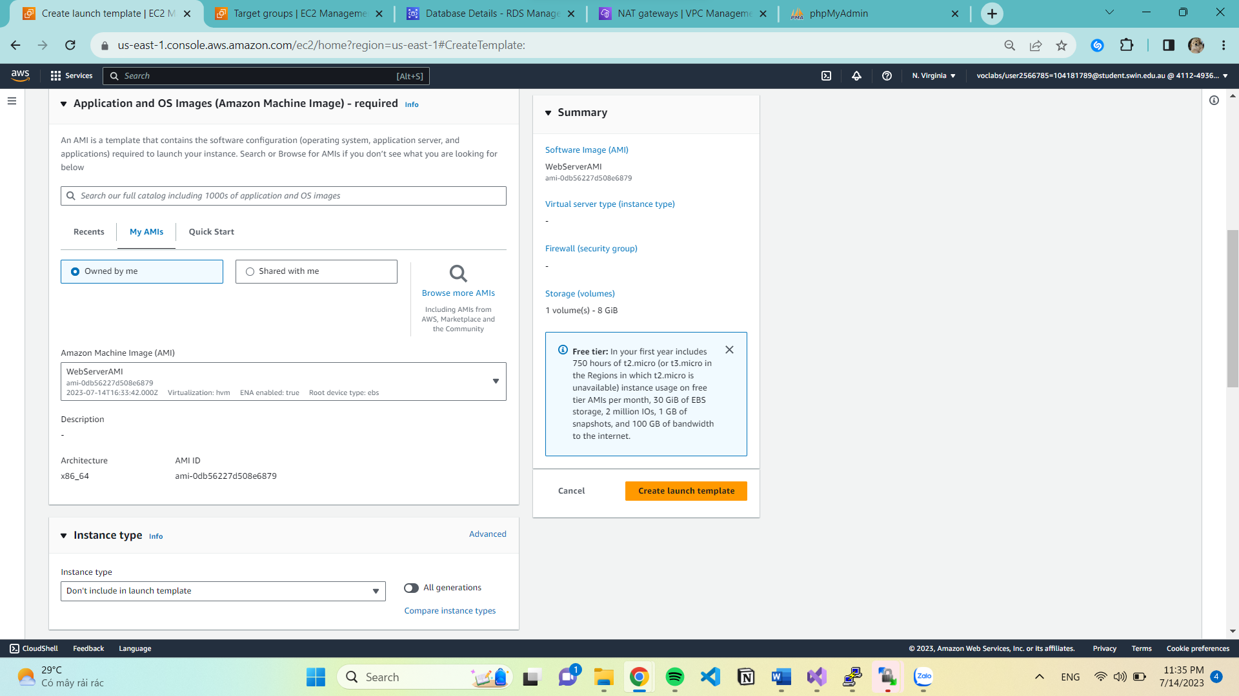

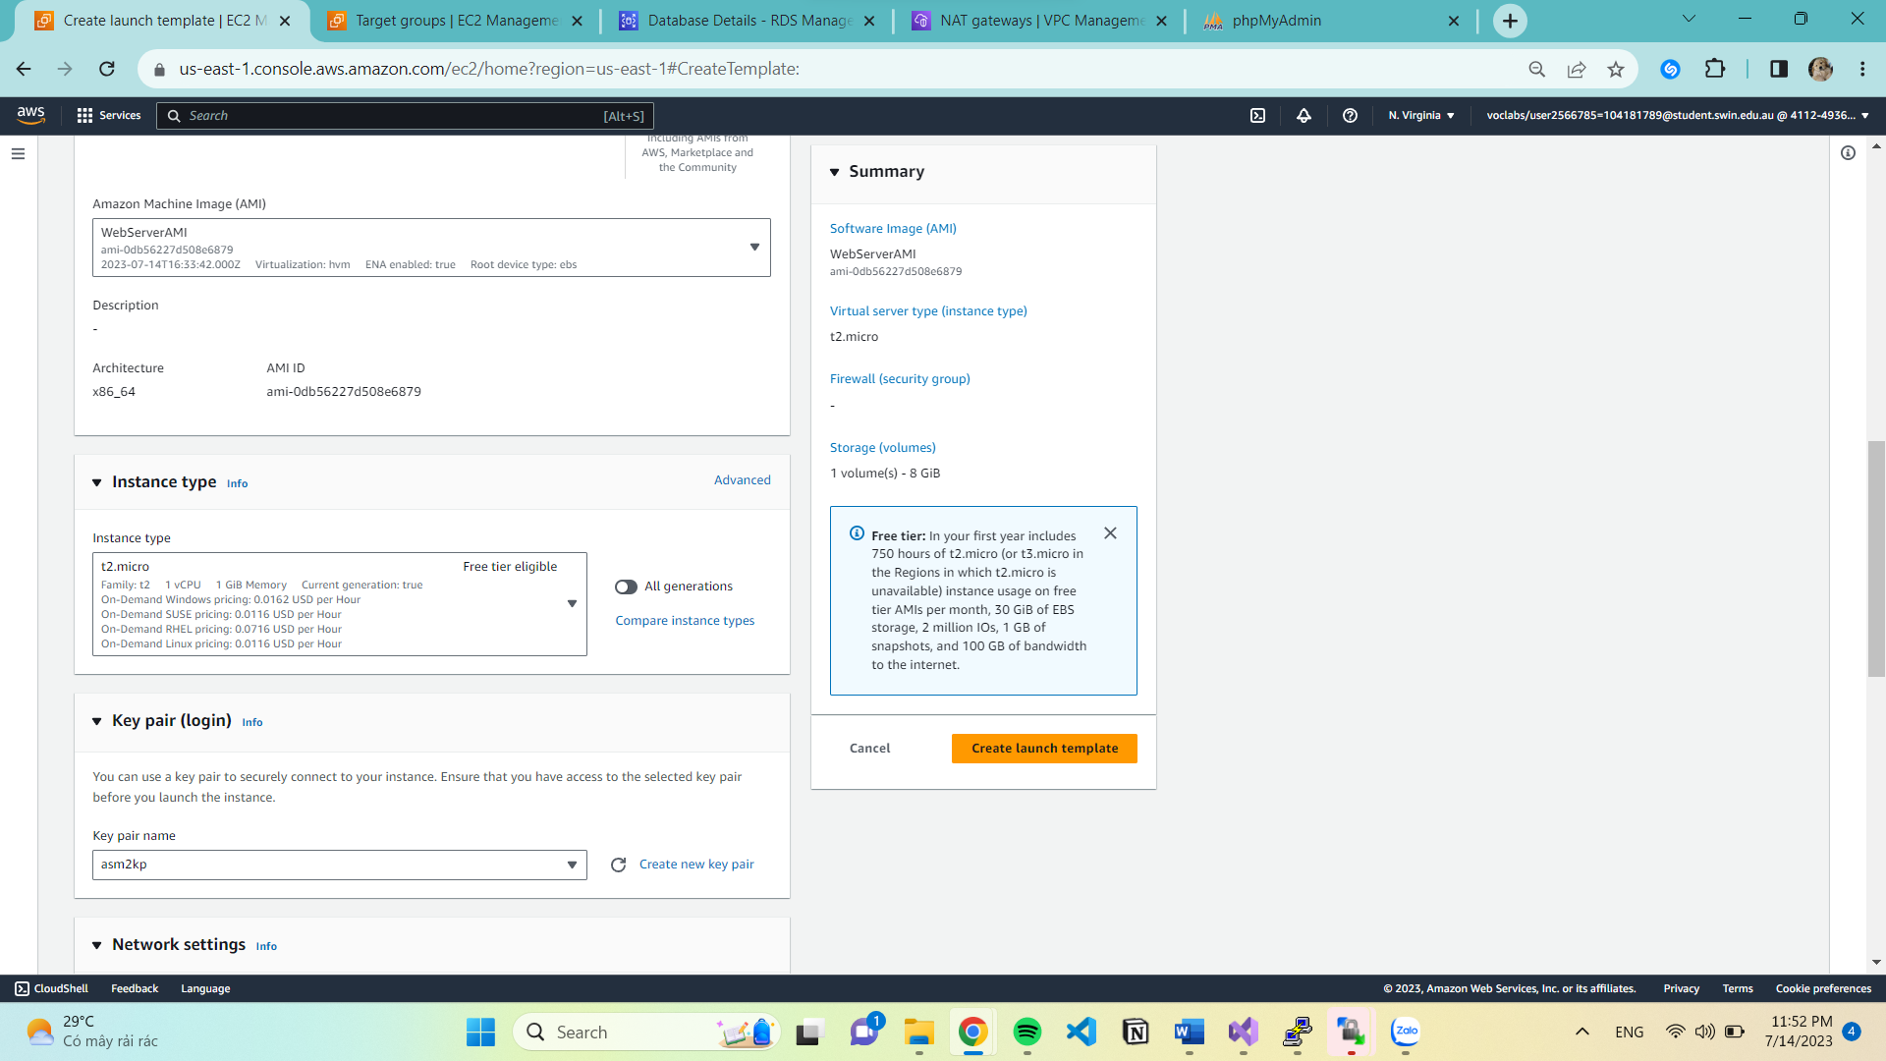

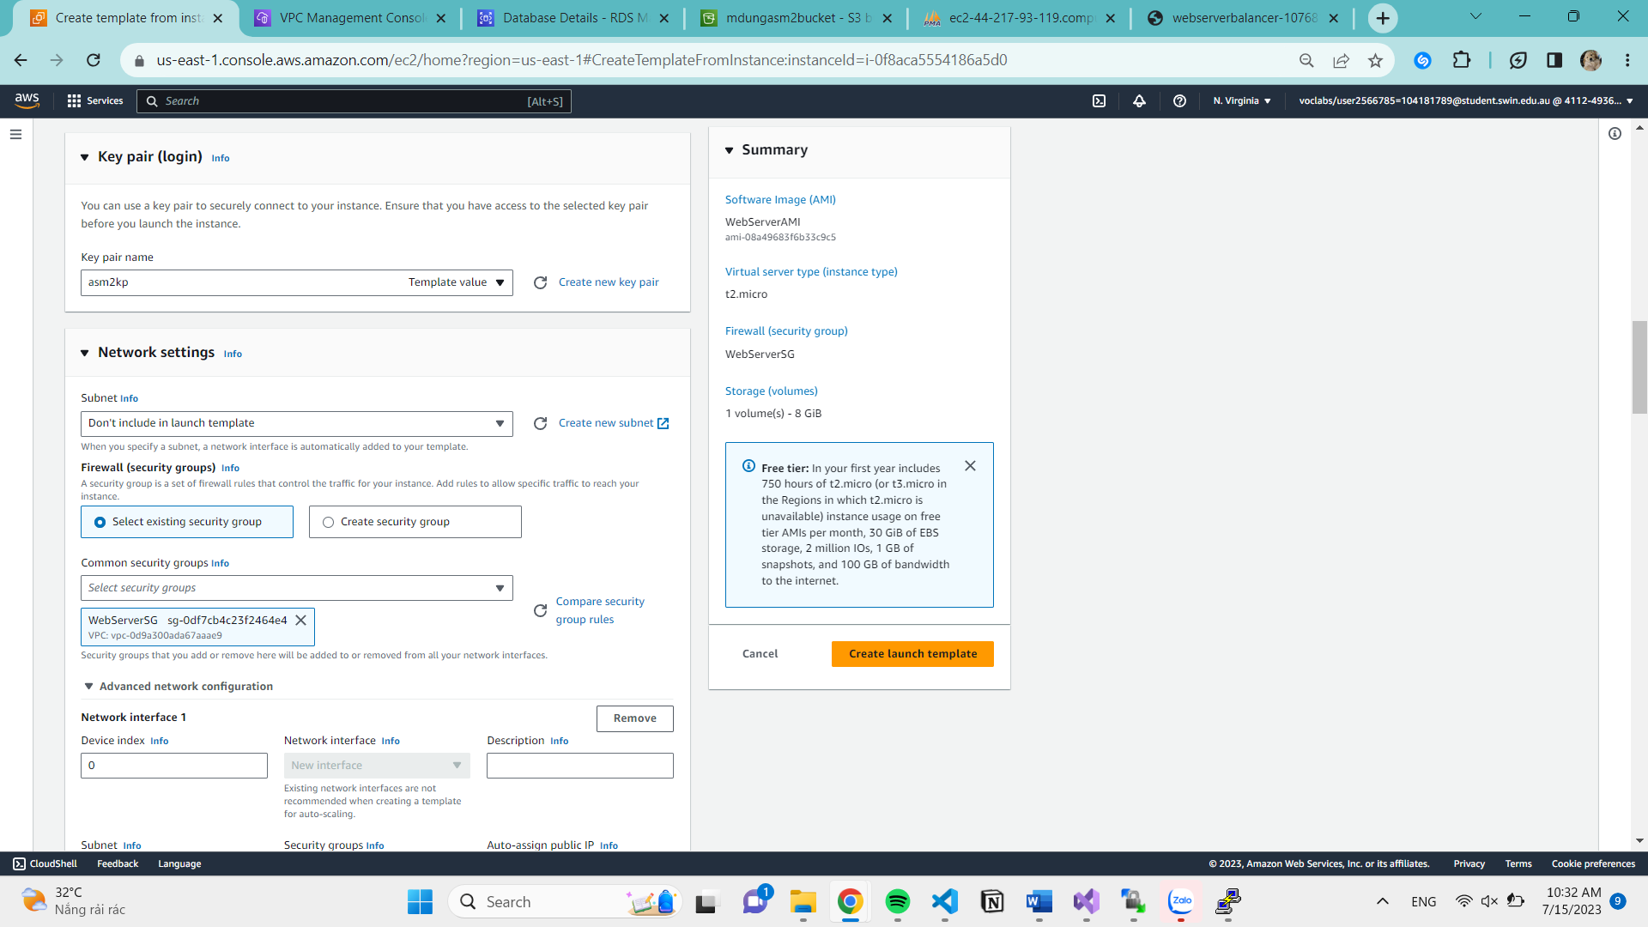

1. **ASG configured and working correctly**

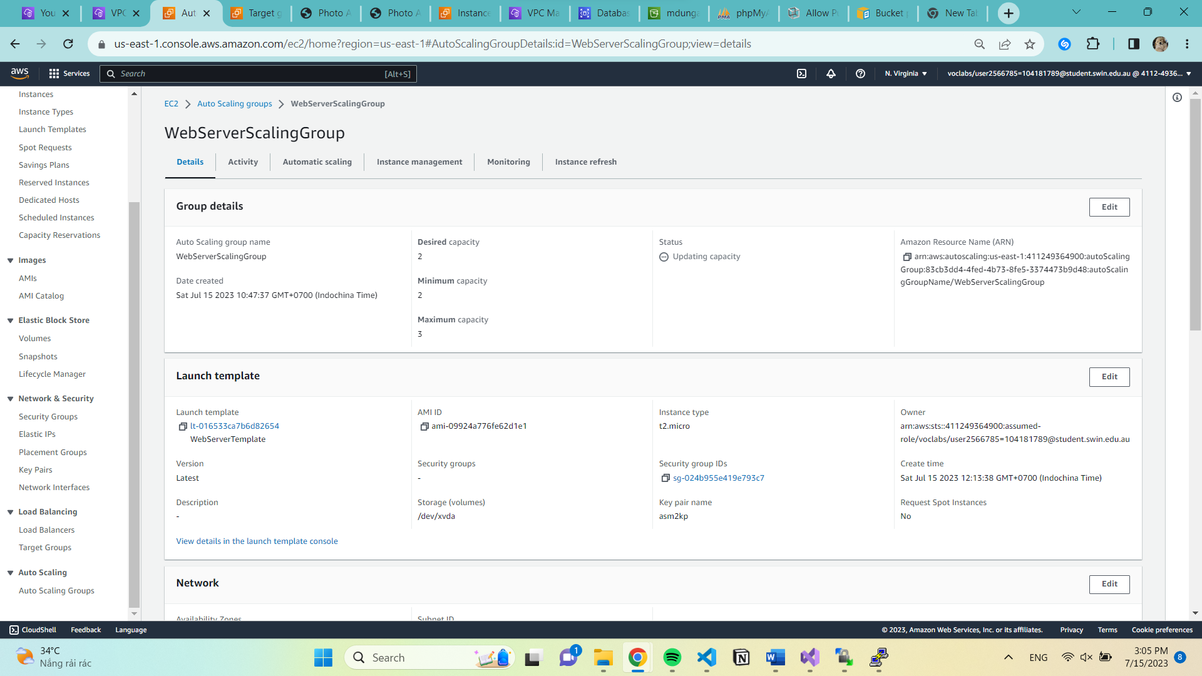

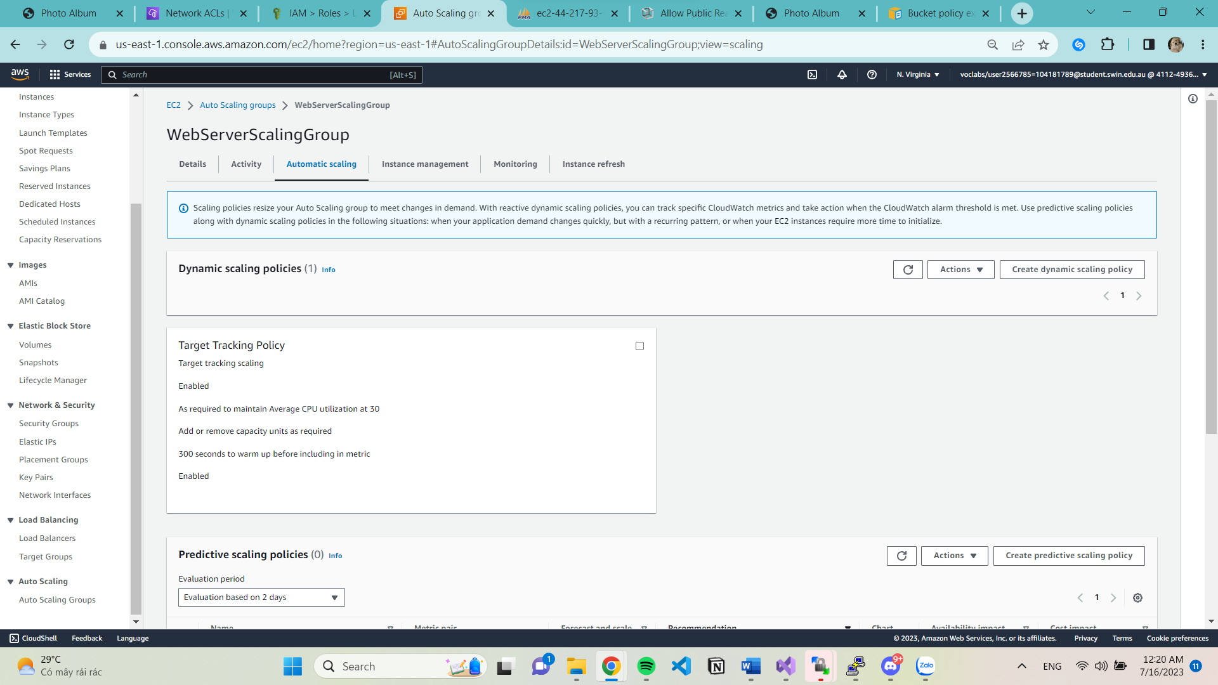

1. **ELB configured and working correctly**

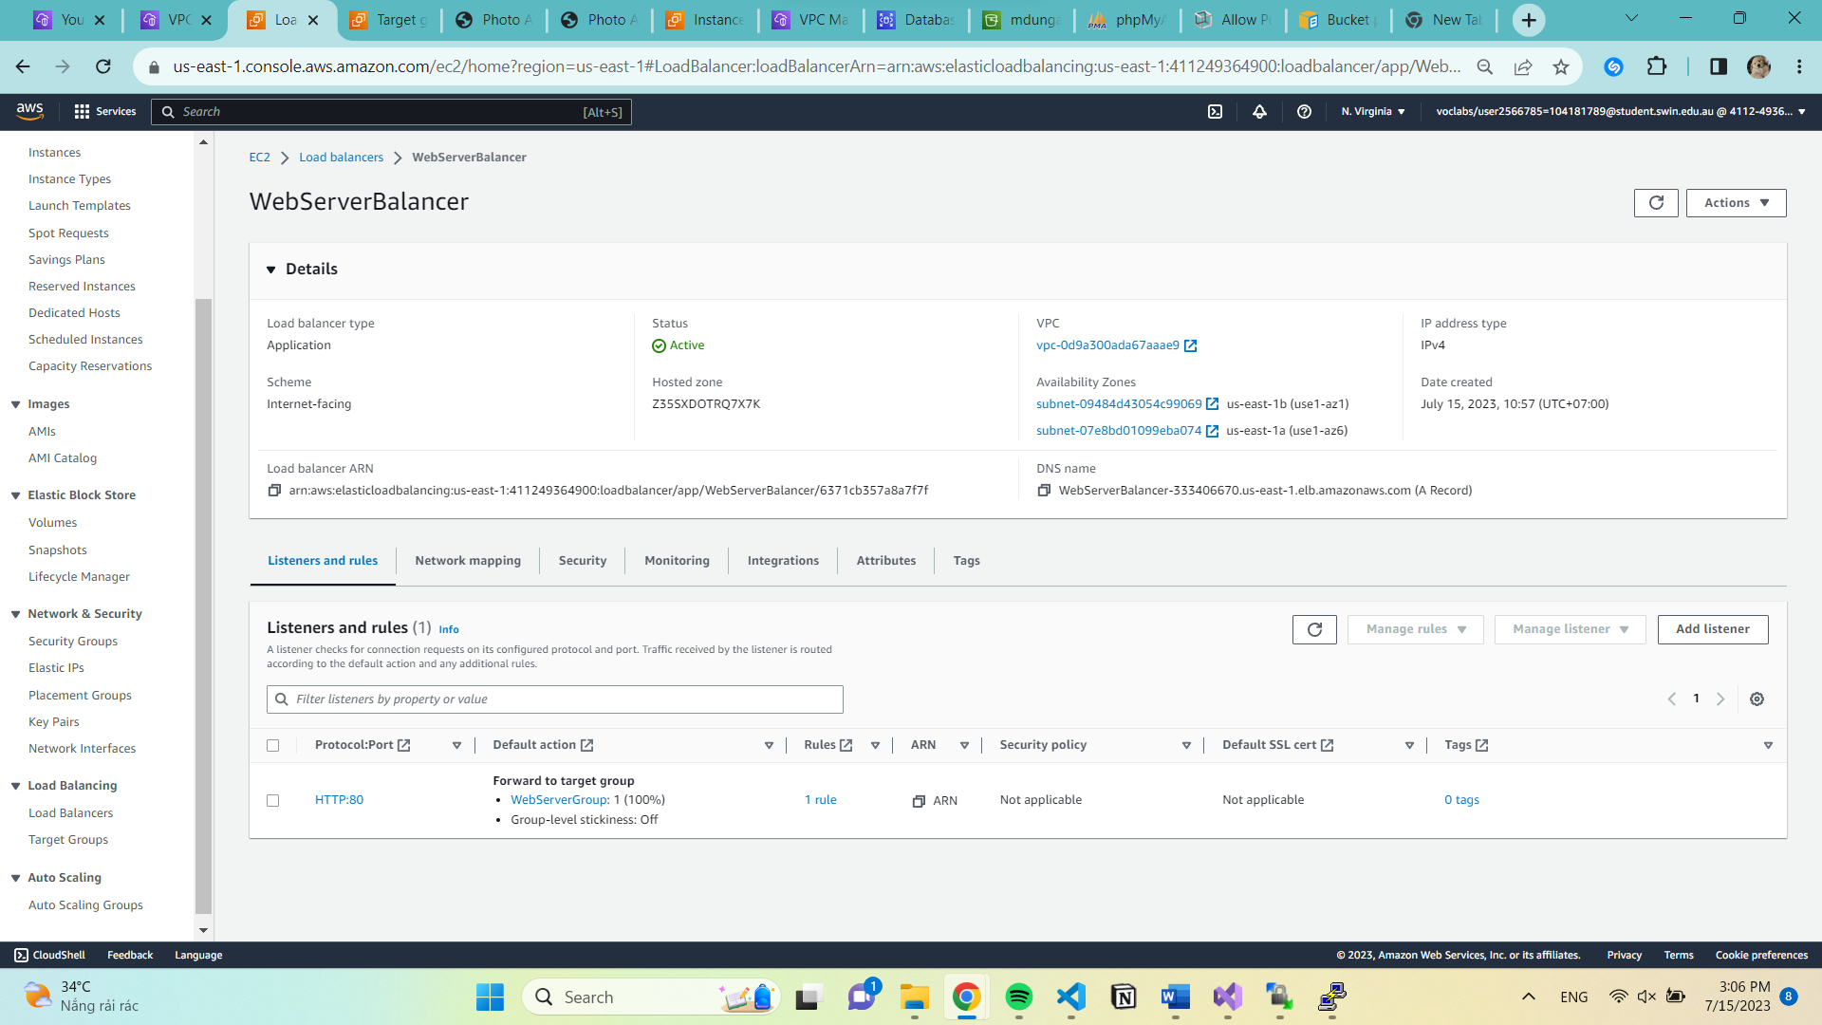

Health check

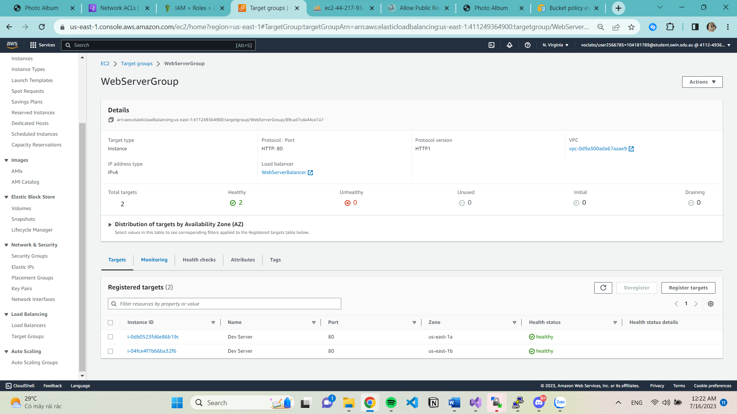

1. **Photos stored in S3 are correctly accessible. S3 bucket policy is correct.**

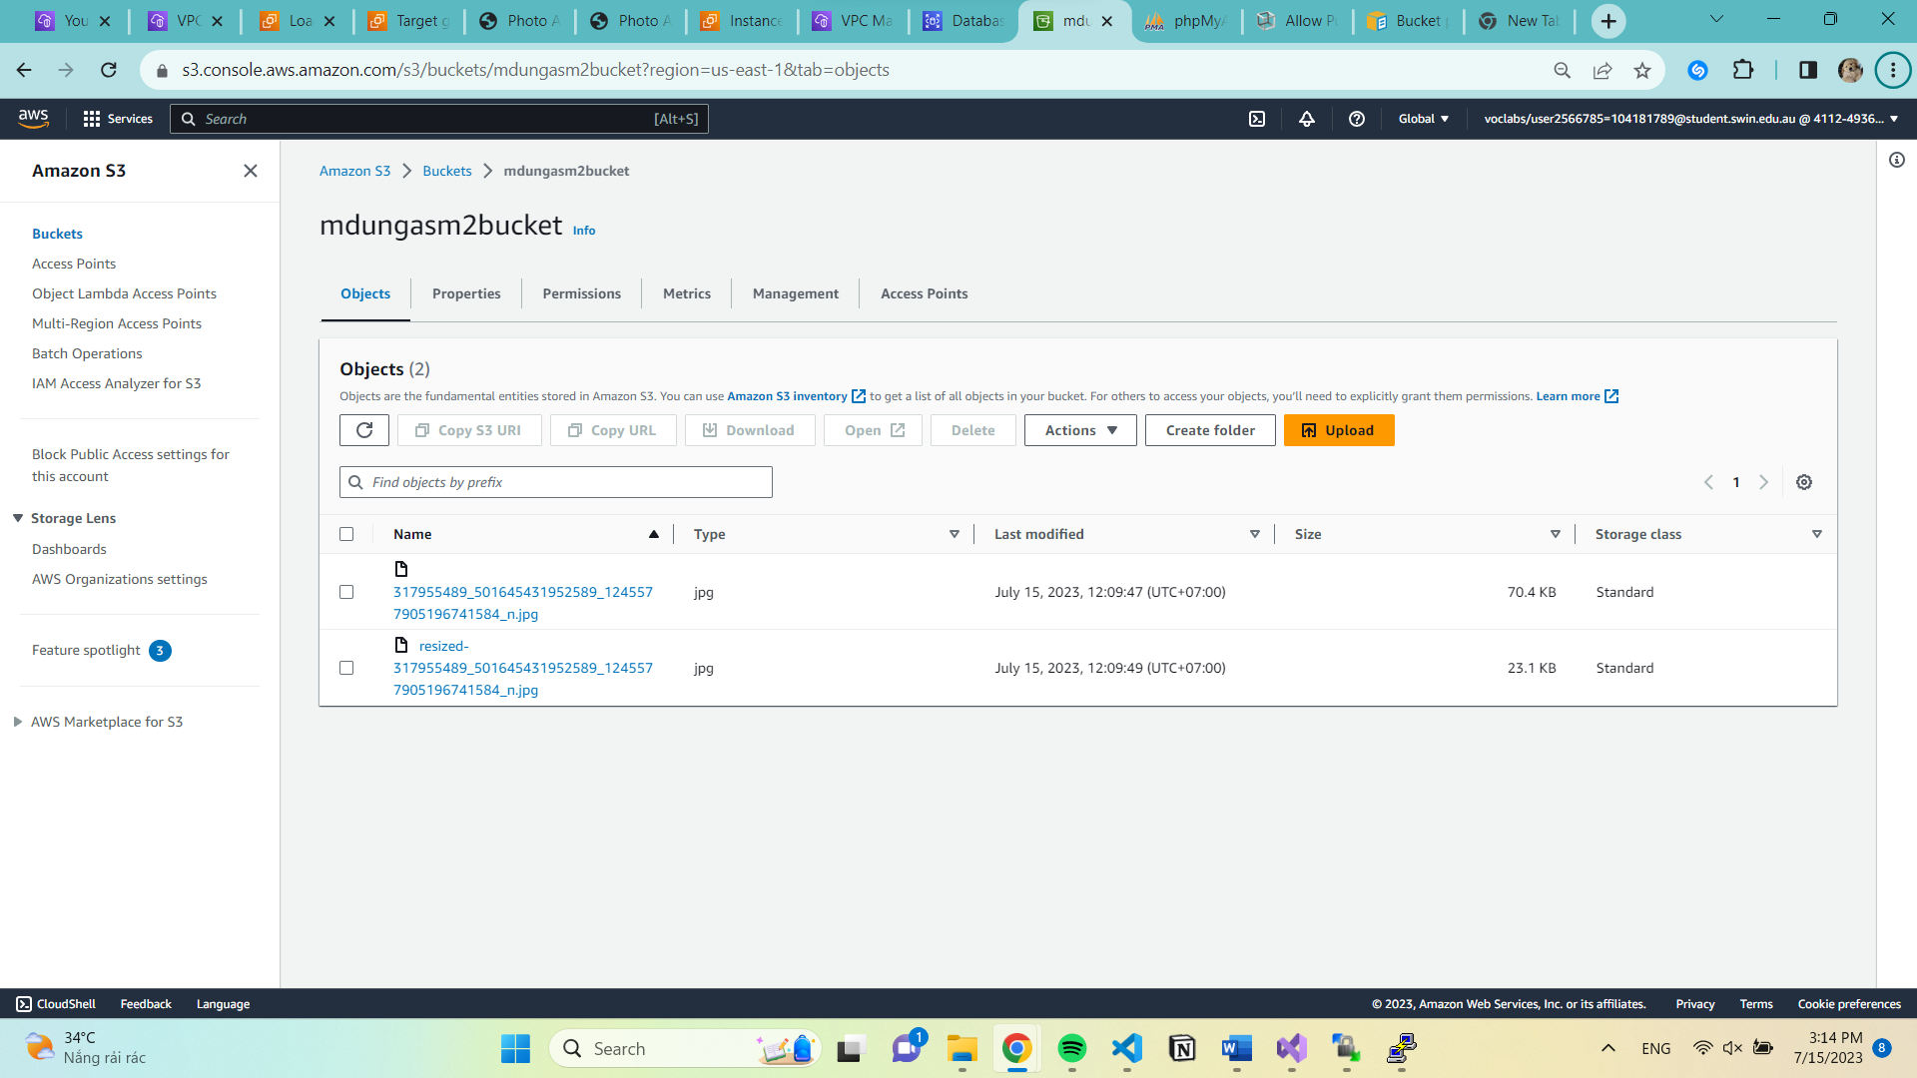

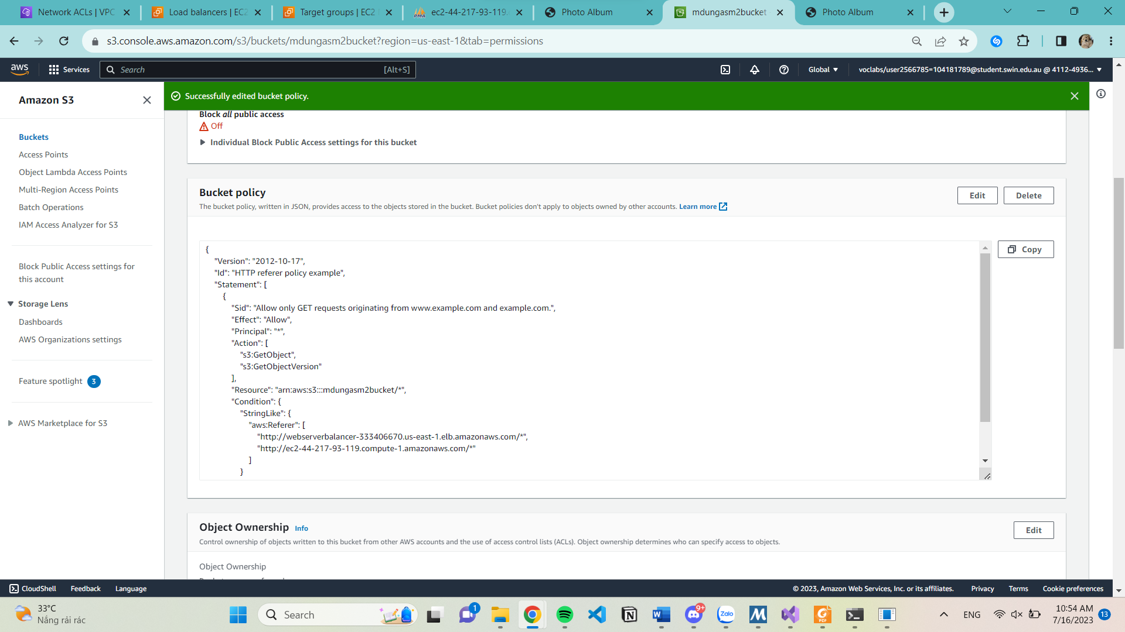

1. **Lambda configured and working correctly.**

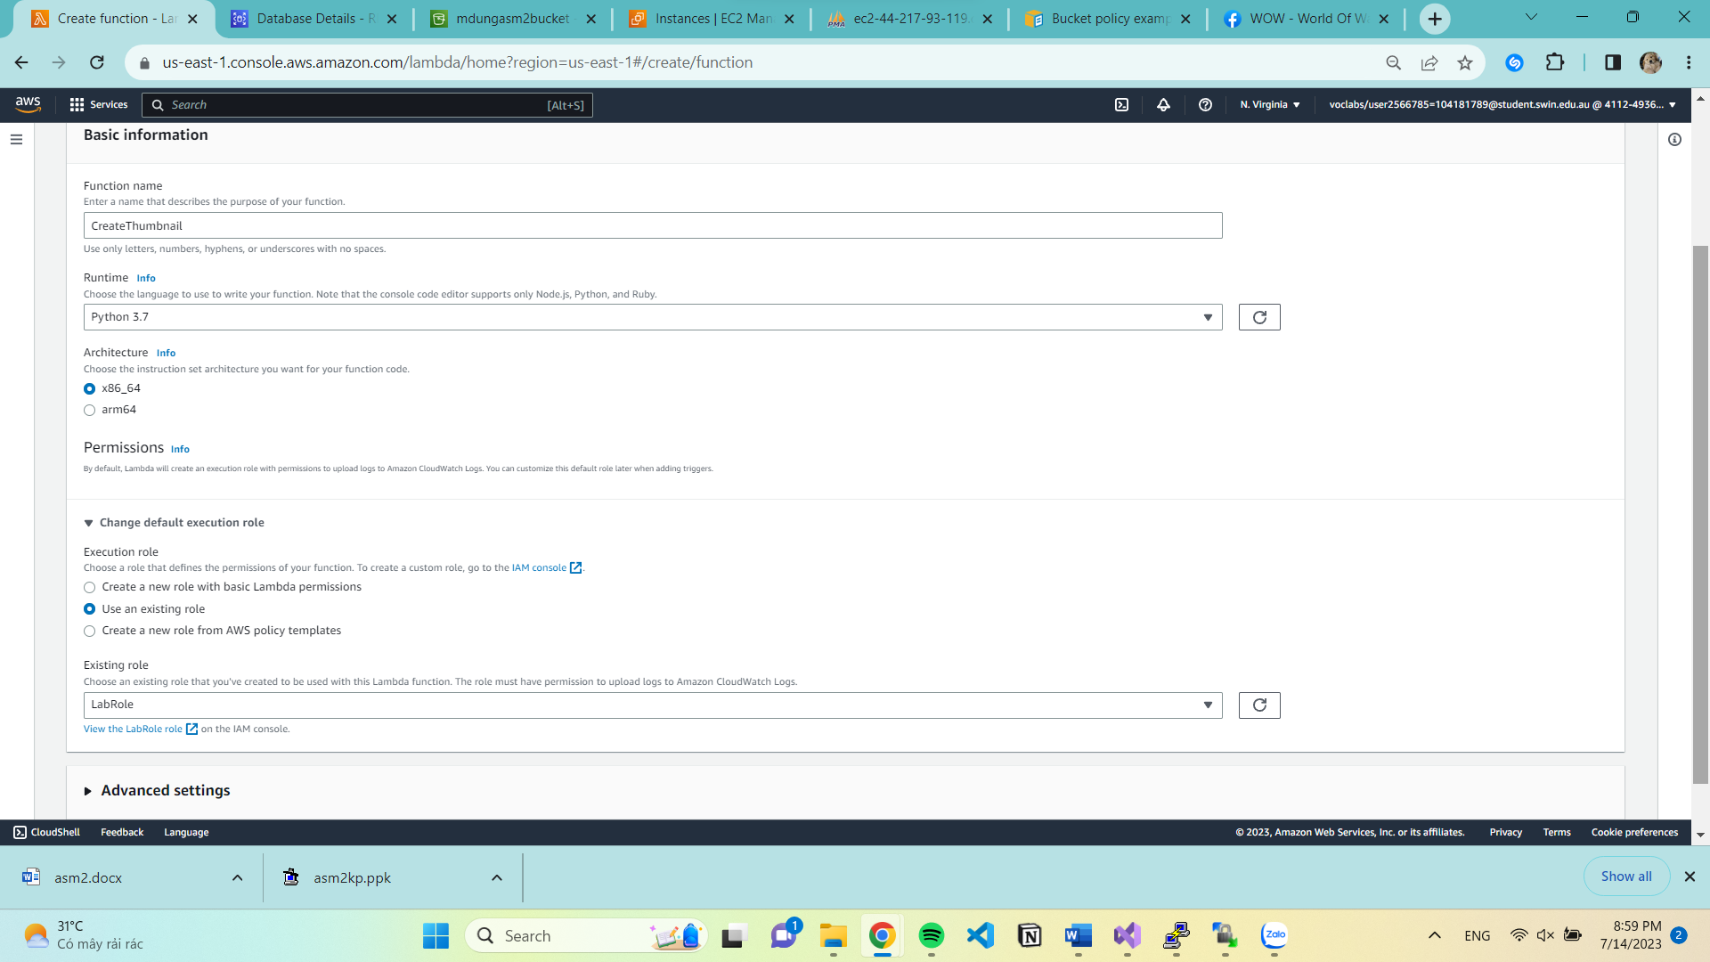

Upload from zip file

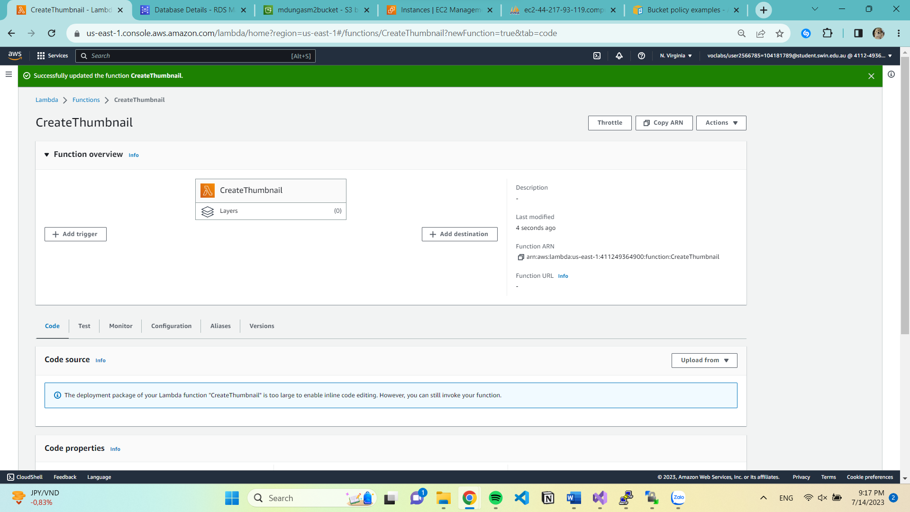

Lambda Role

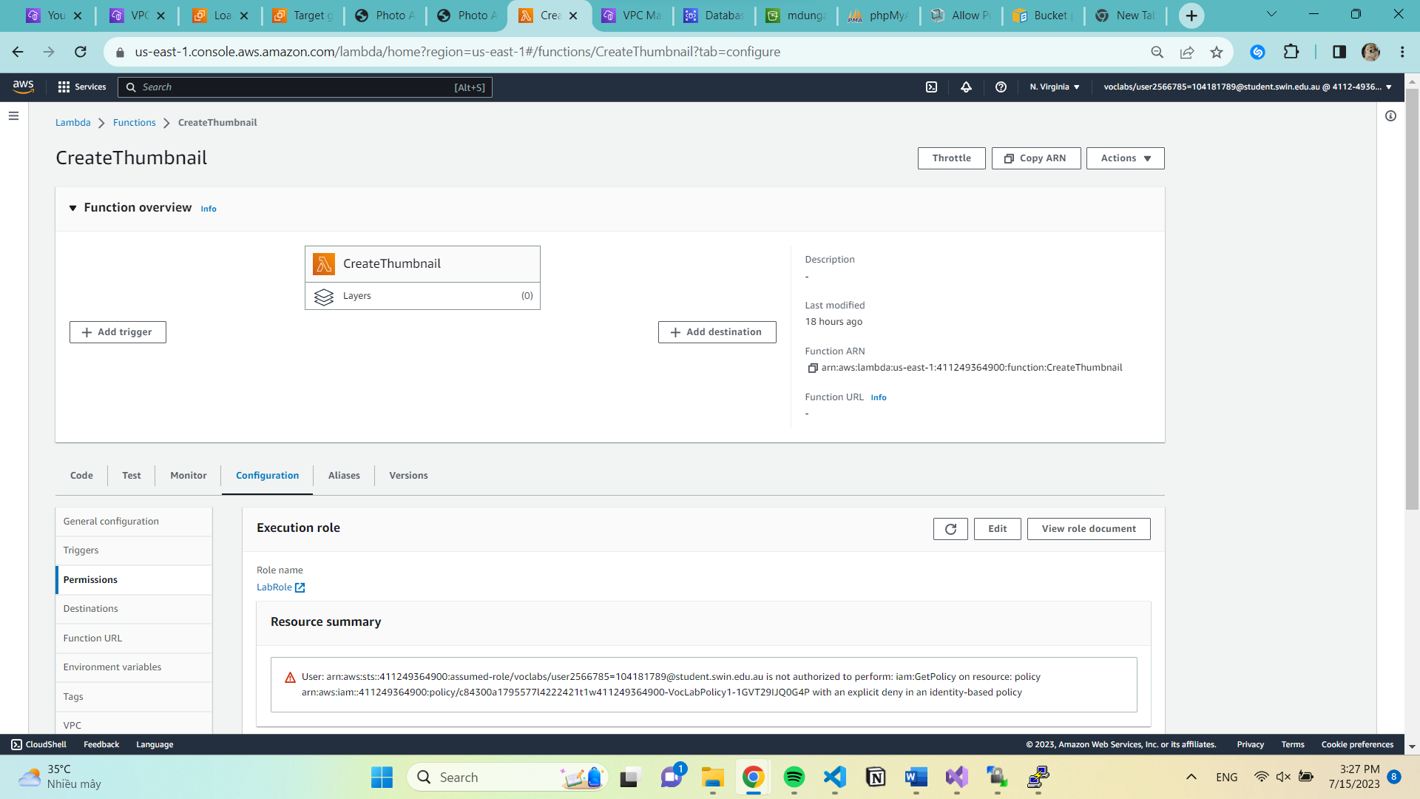

1. **RDS configured and working correctly**

Create RDS Database

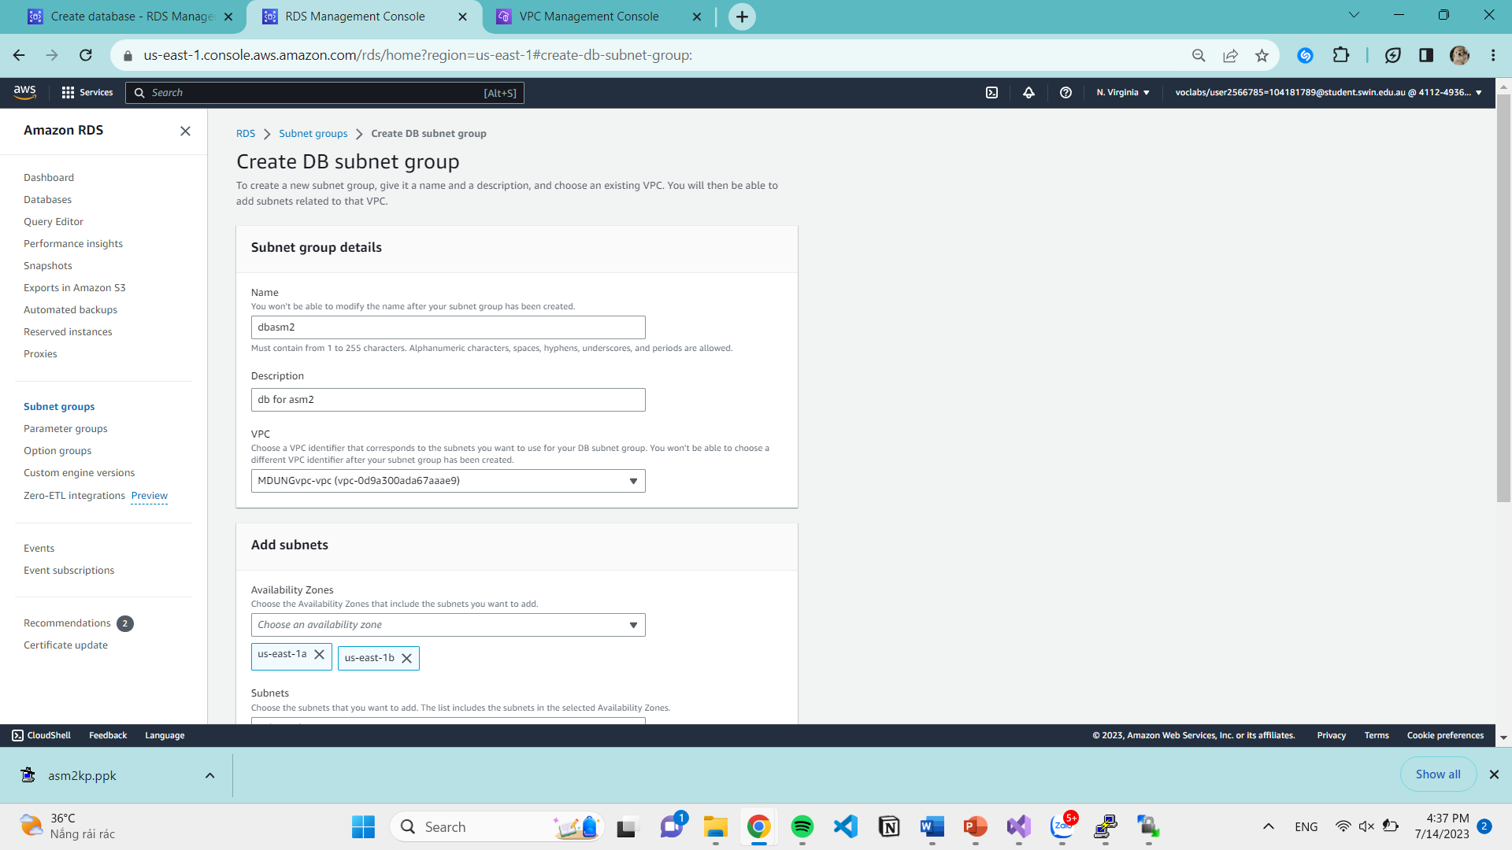

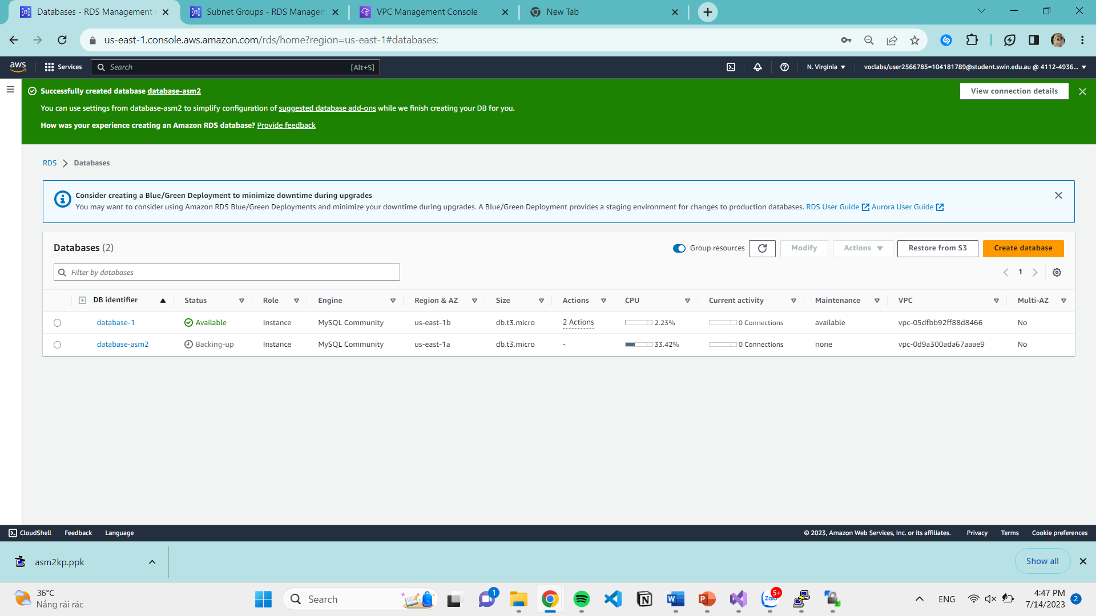

1. **Functional requirements**
2. **Website accessible via ELB**

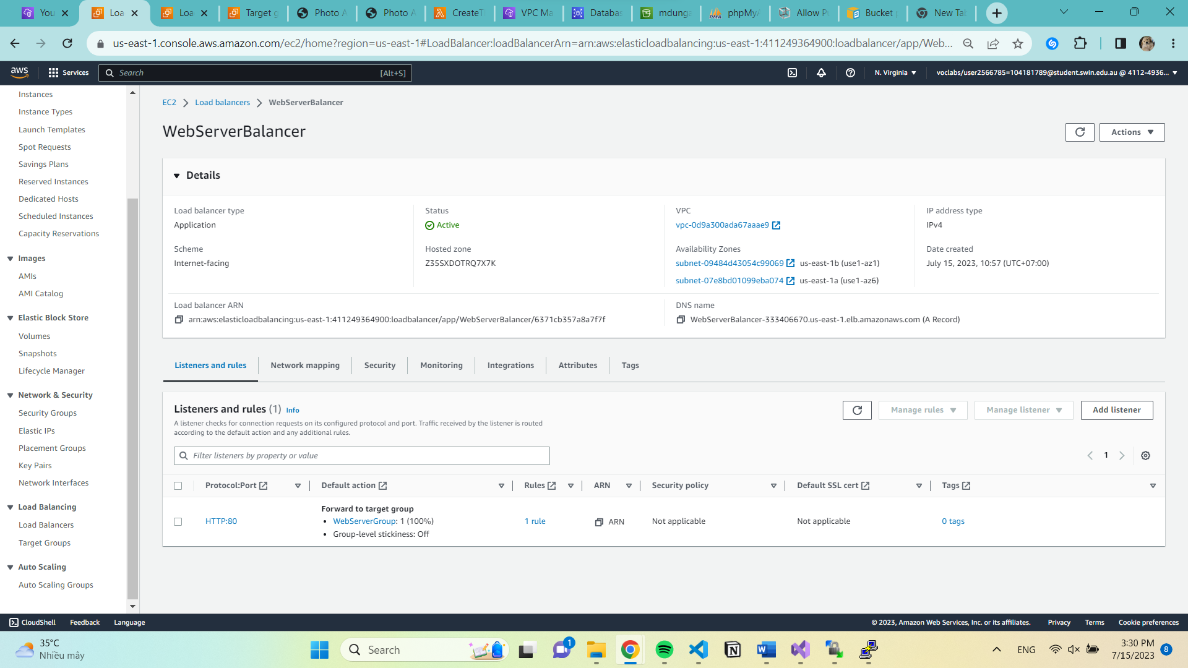

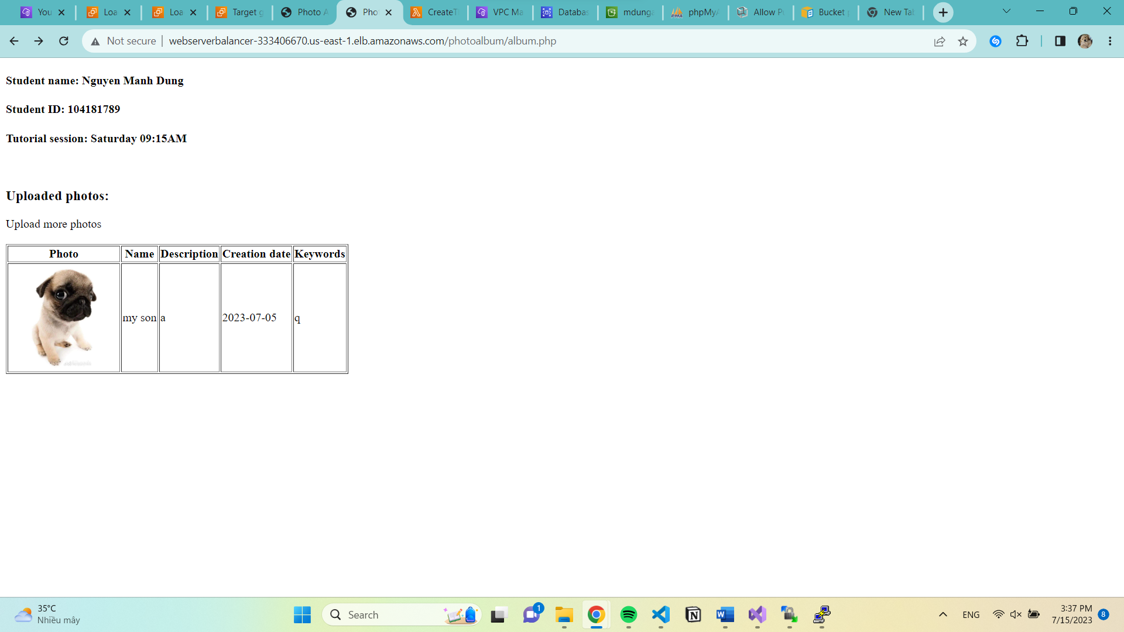

1. **Photos** **and** **their meta-data displayed on album.php page**

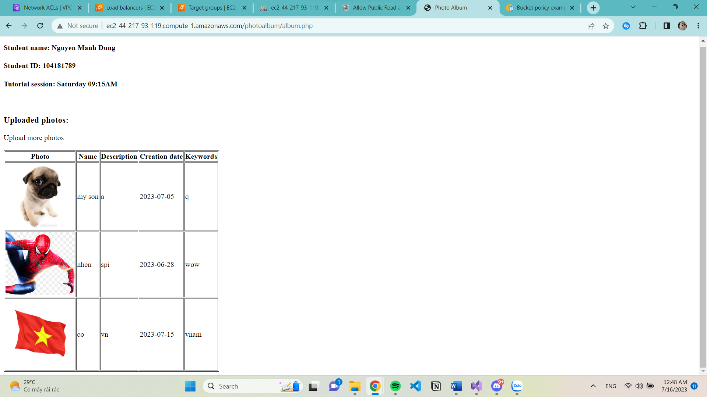

1. **Photos and their meta-data can be uploaded to the S3 bucket and RDS database, respectively**

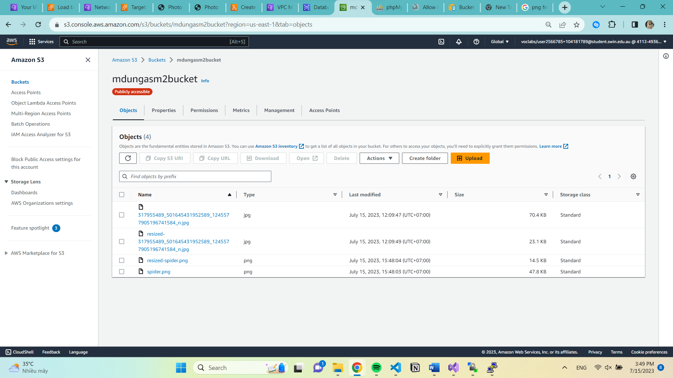

The photographs are shown not only in the album .php but also in the S3 bucket and phpmyadmin.php once they have been uploaded using the photouploader.php website.

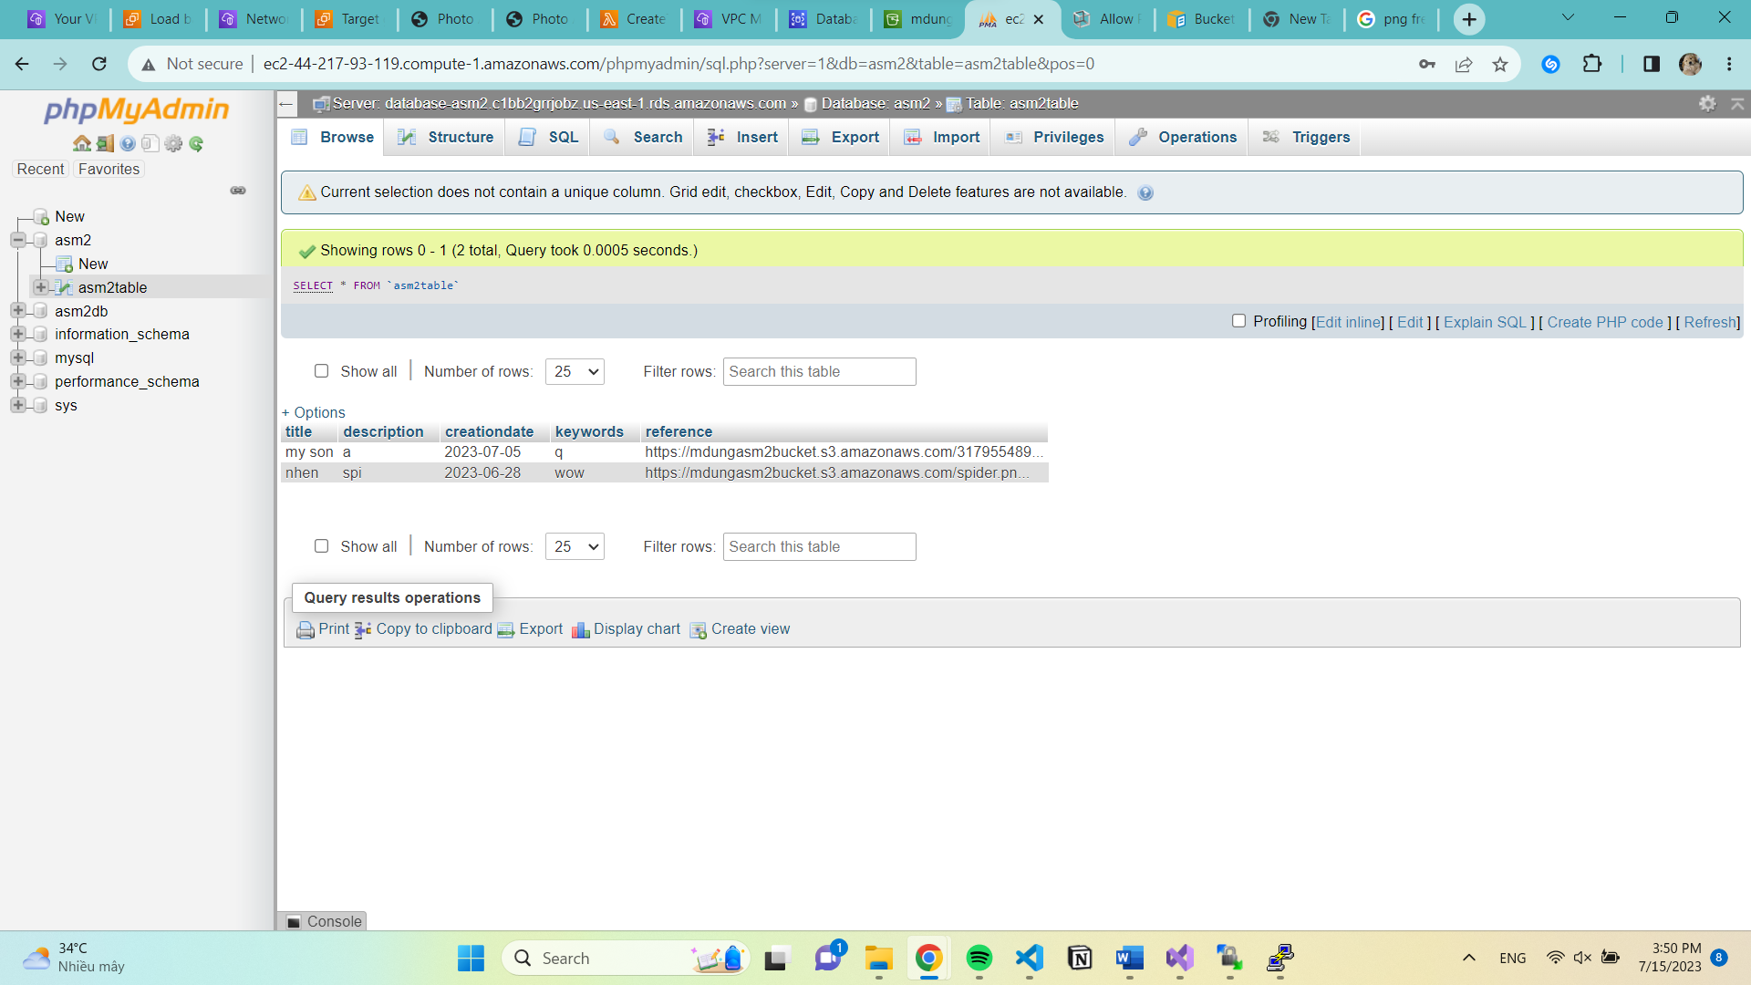

1. **Photos are resized by the Lambda function**.

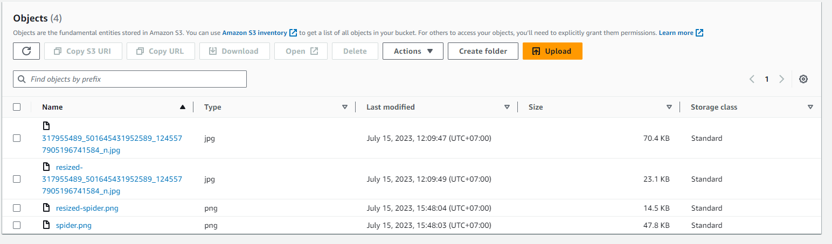

Submission Checklist

Student Name: ……Nguyen Manh Dung …………………………………………

Student Id: ……104181789……………………………………………….

Tutorial time: ……13PM-17PM Saturday……………………………………………

Date of submission: ...........15/07...............................

1. Some configuration needed

Download myphpAdmin

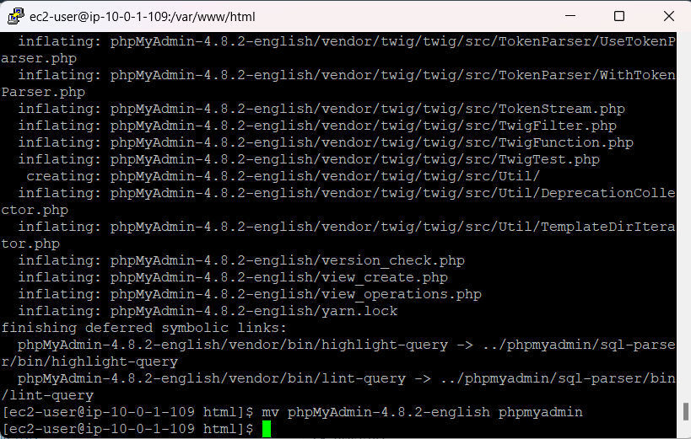

Create a Database table

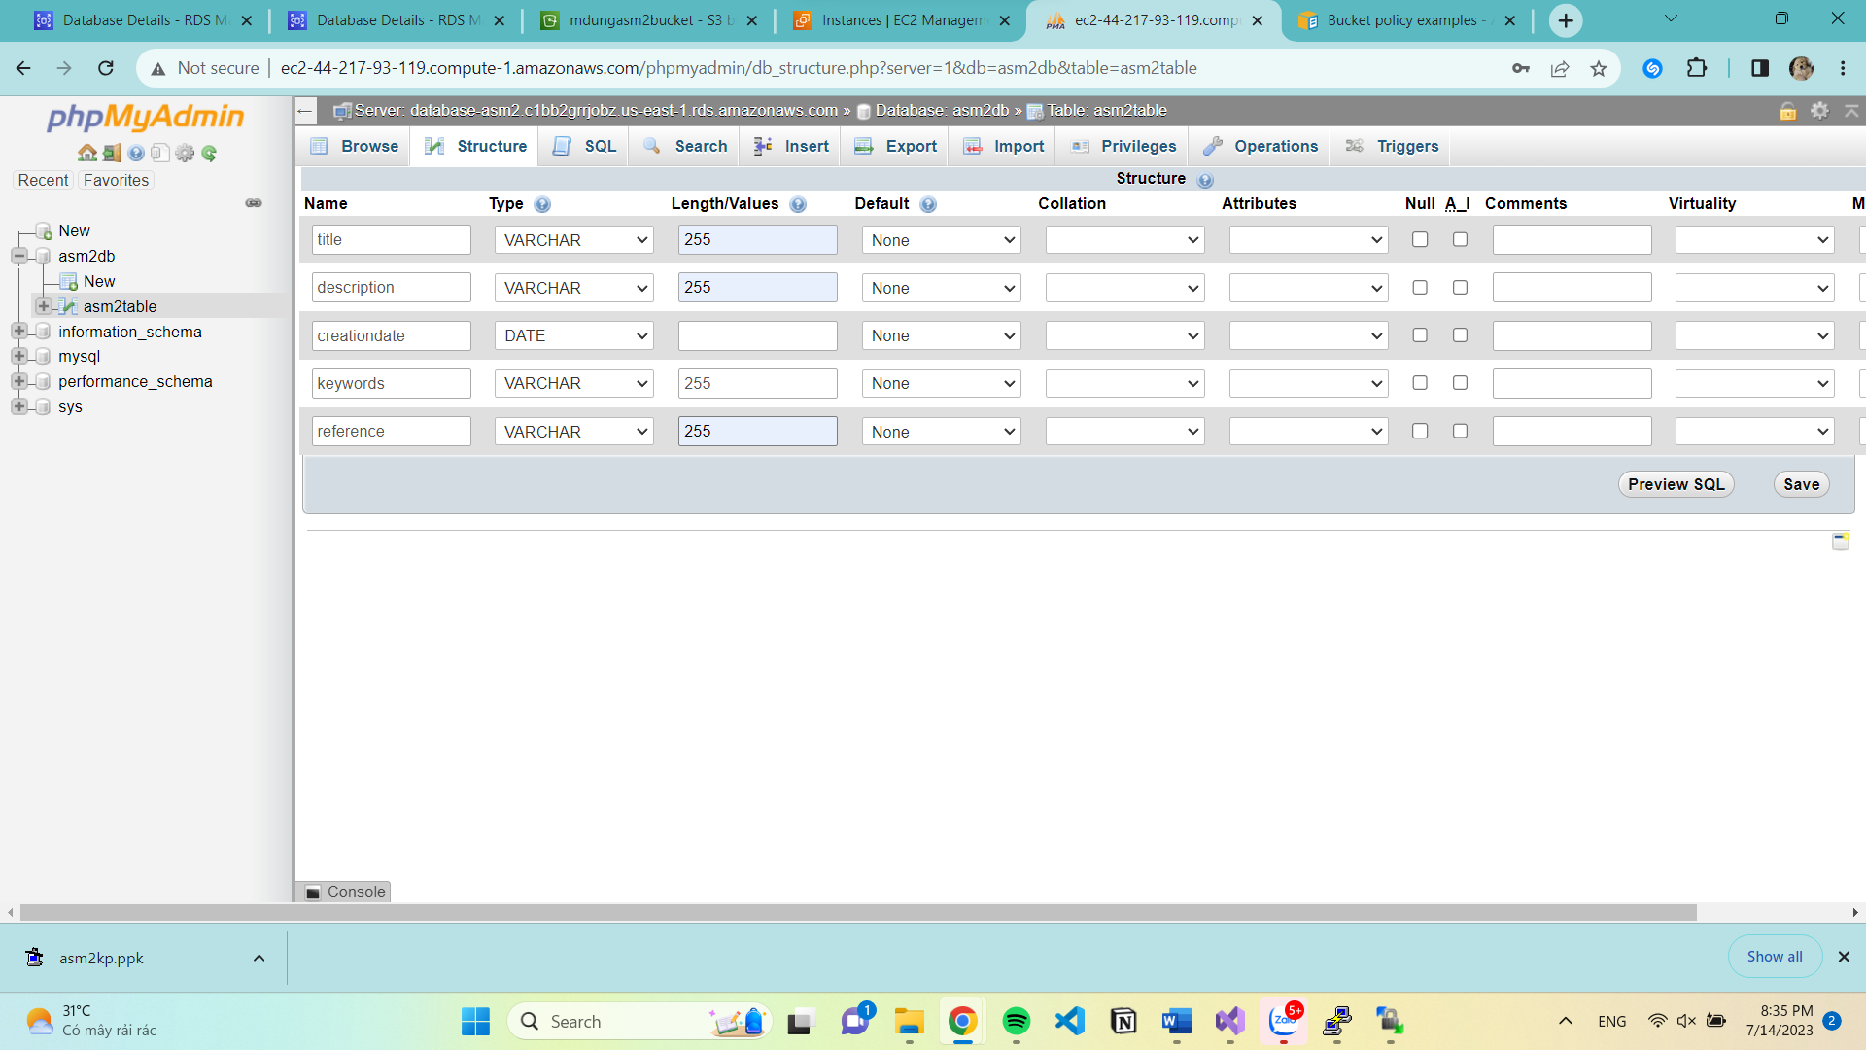

Download aws

